• Create a virtual network with 2 subnets. Each subnet should have 16 Ips only.

Following are the steps

* Search VPC

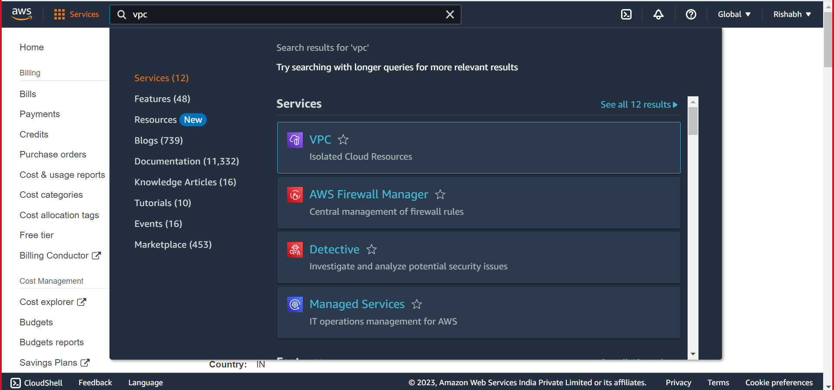

* Click on Create VPC

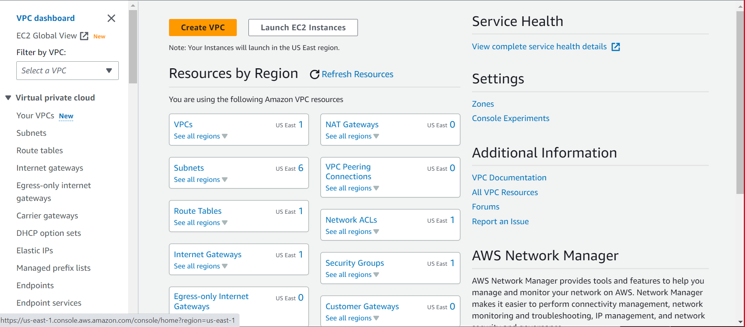

* Fill information as shown + click on create.

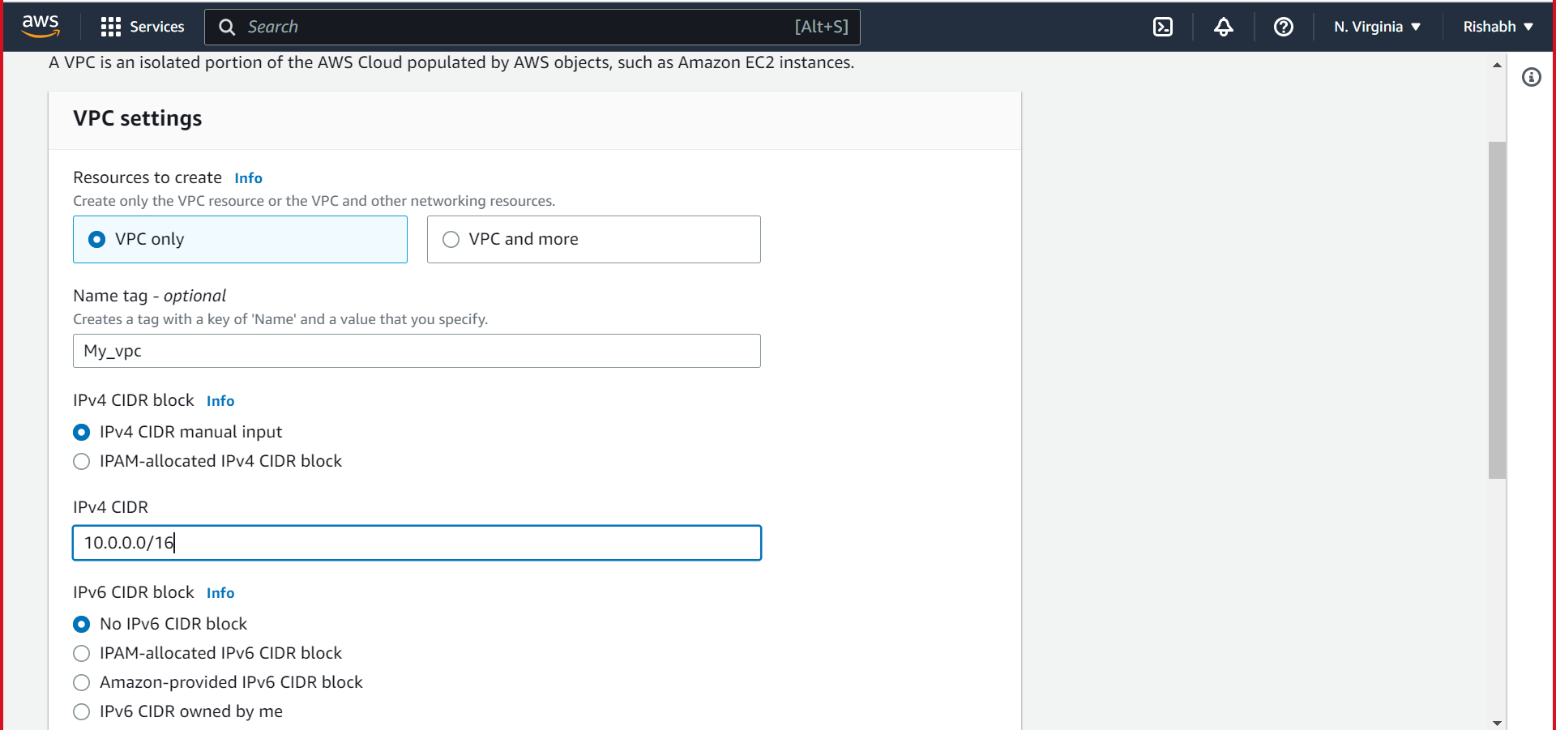

* Created.

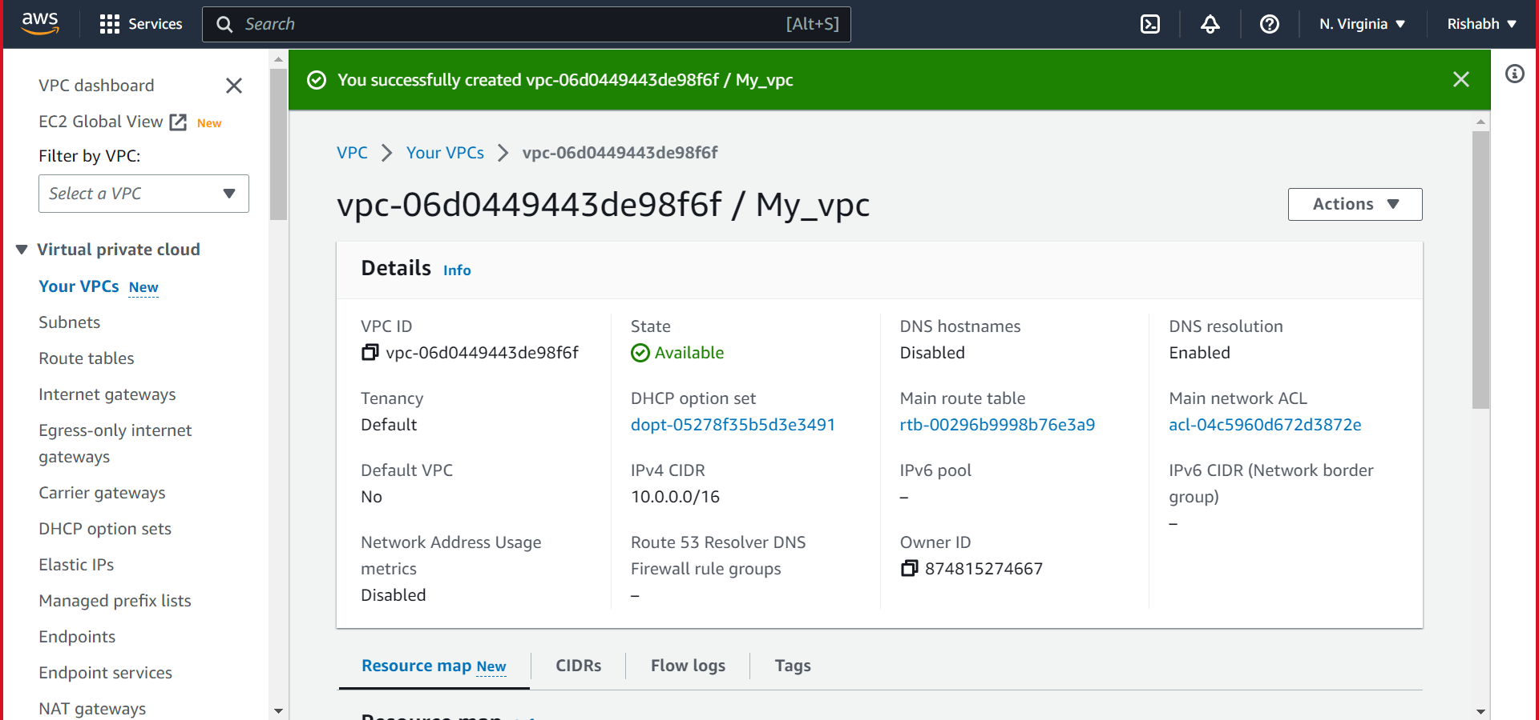

* Click on create subnet

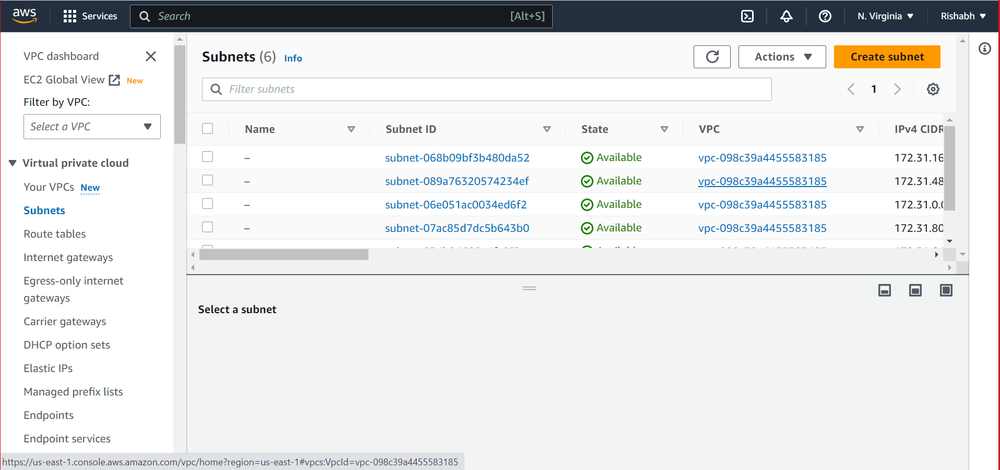

* Fill information as shown + click on create subnet

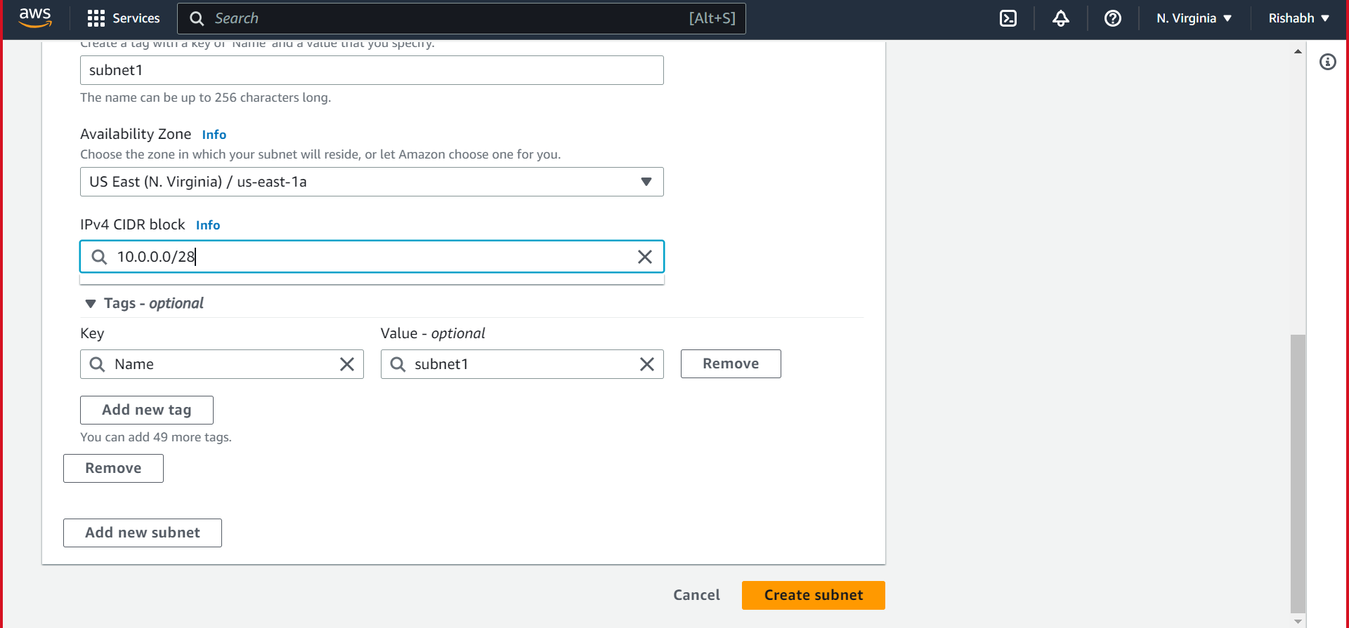

* To create subnet 2 fill as shown + click on create subnet.

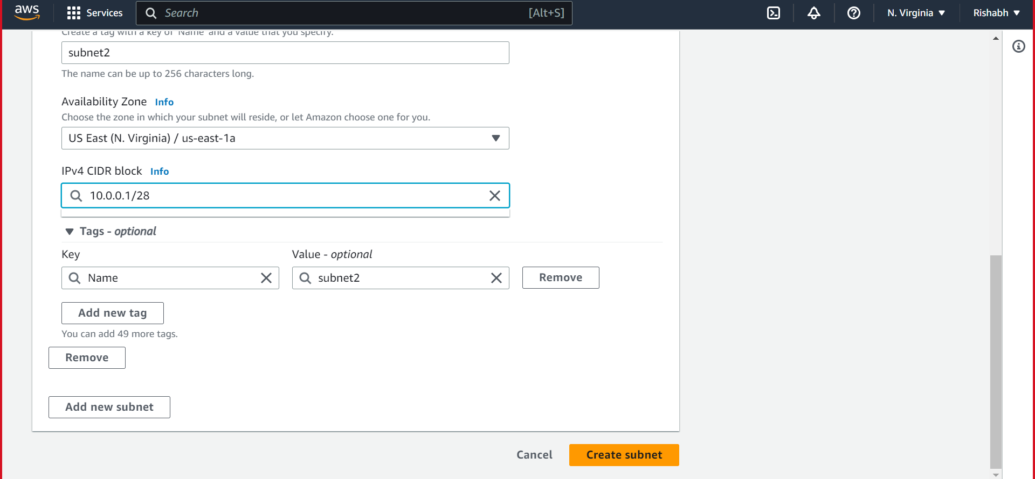

* Create internet gateway.

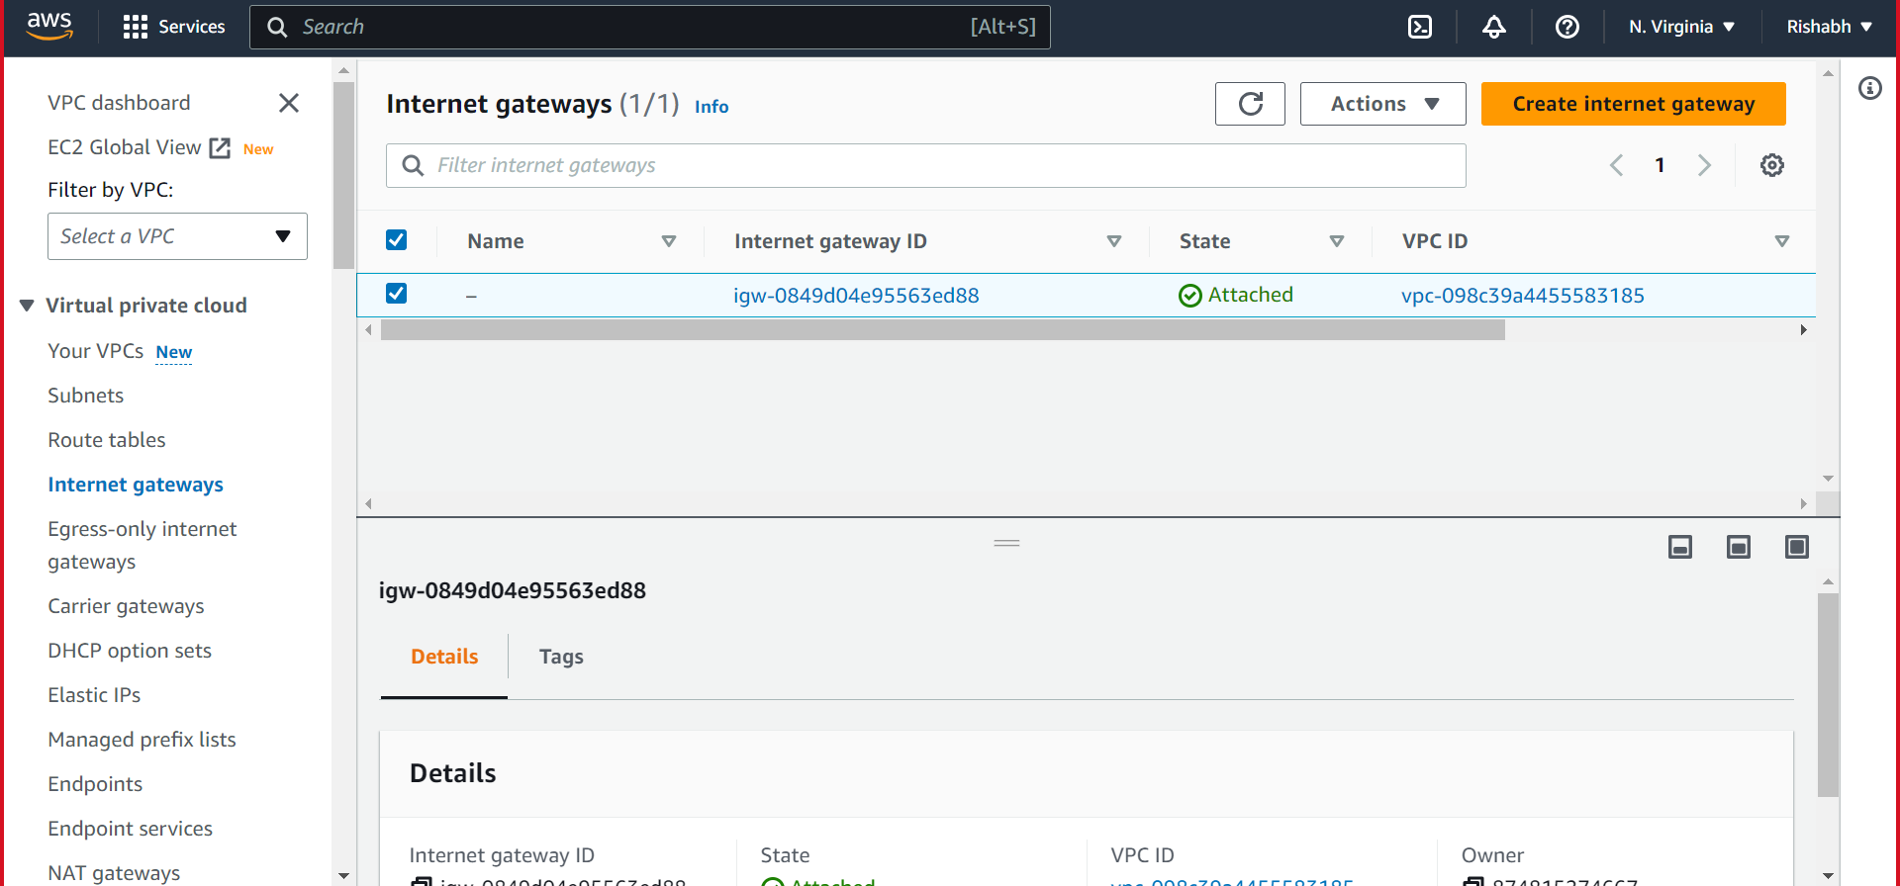

* Fill as shown + click on create internet gateway.

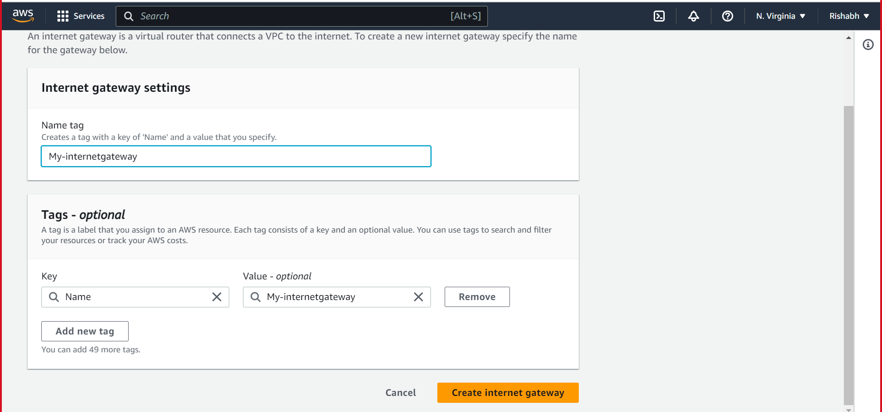

* Created

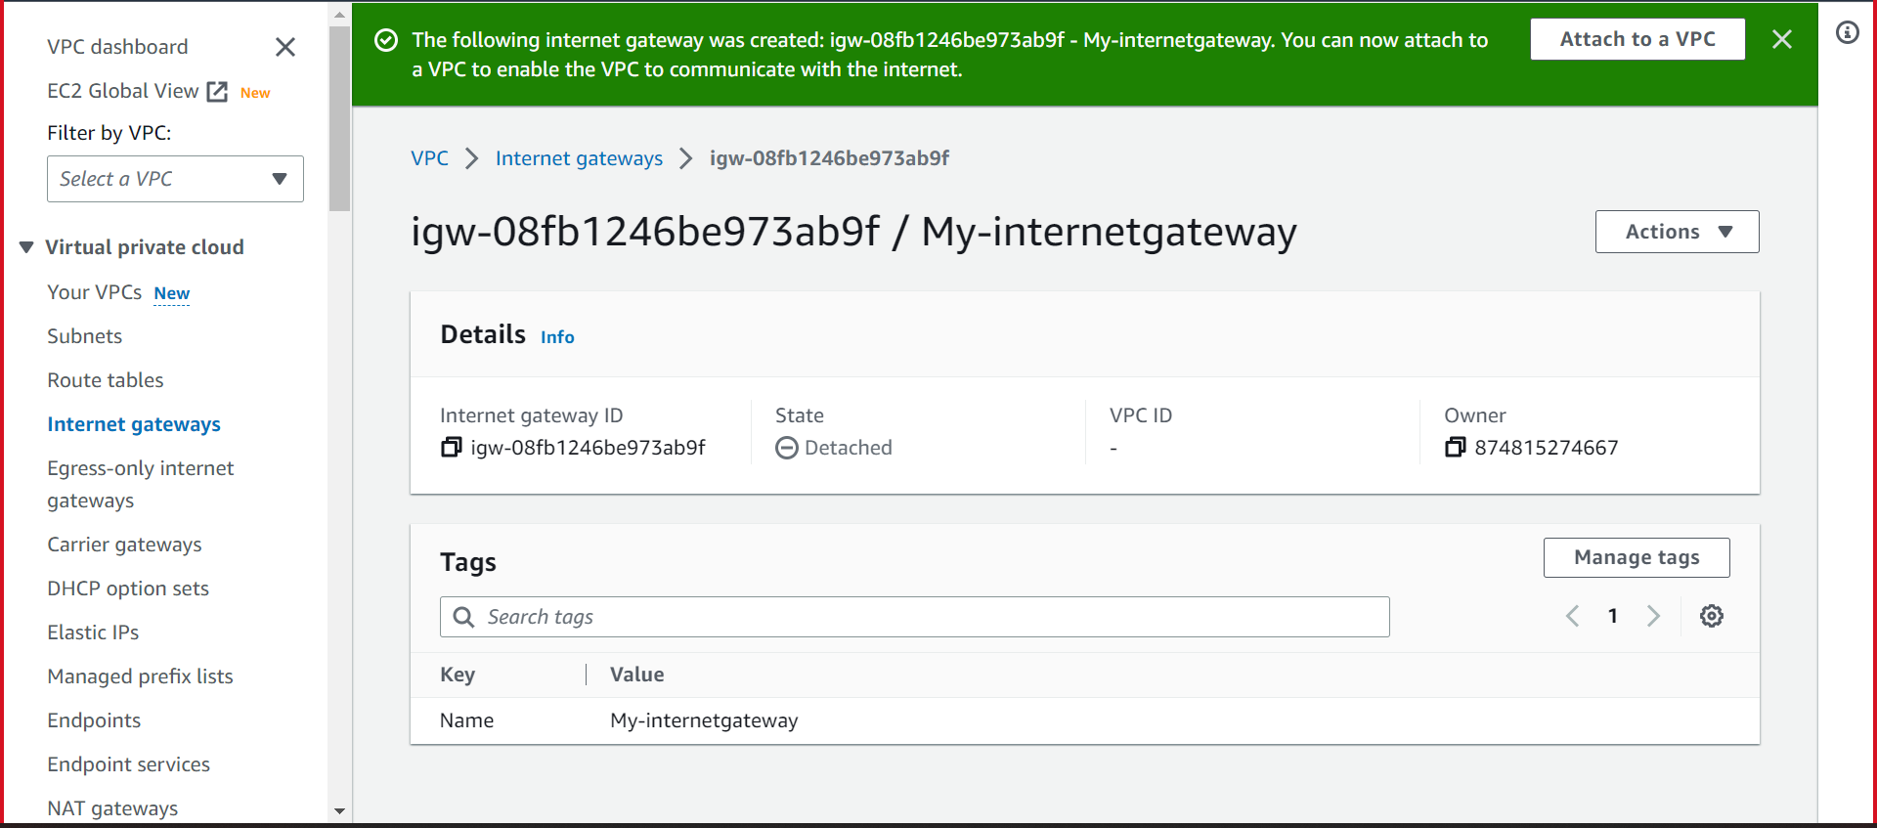

* Attach to VPC

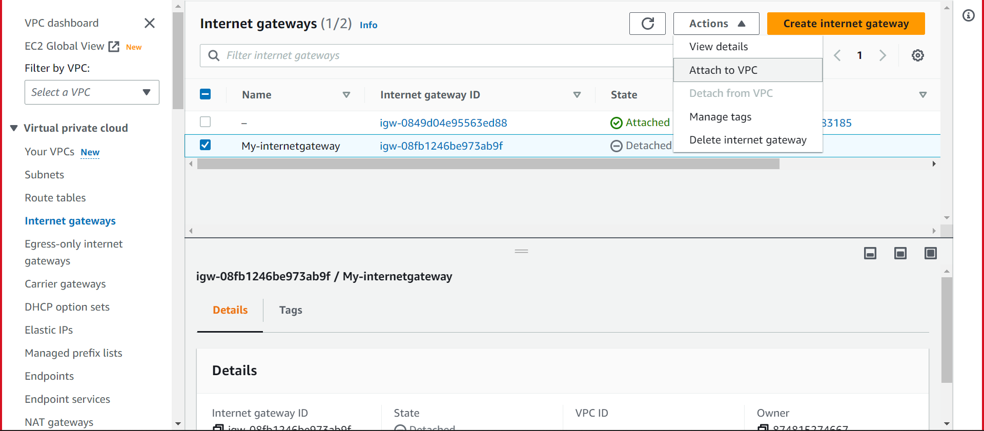

* Create route table

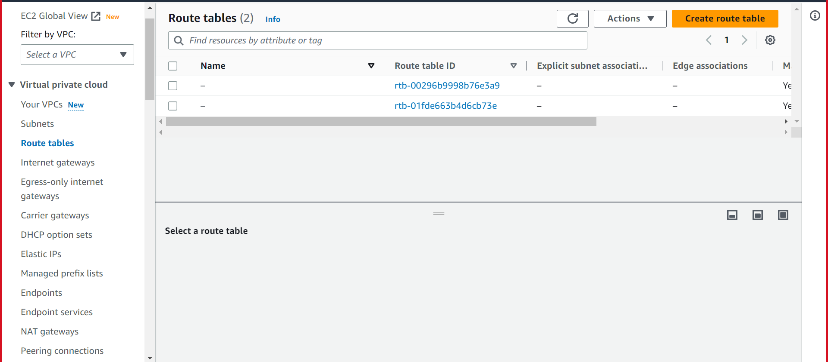

* Fill as show and click on create route table.

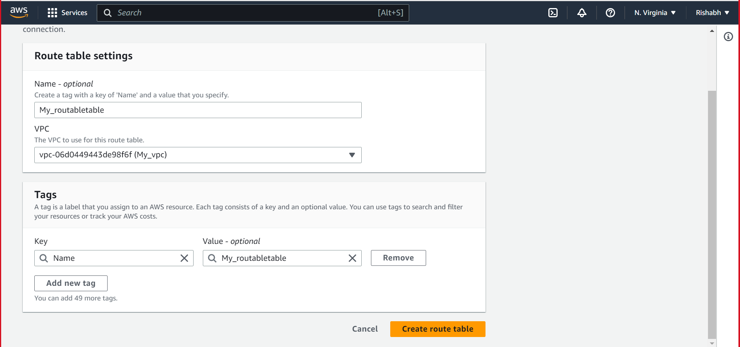

* Click Edit routes

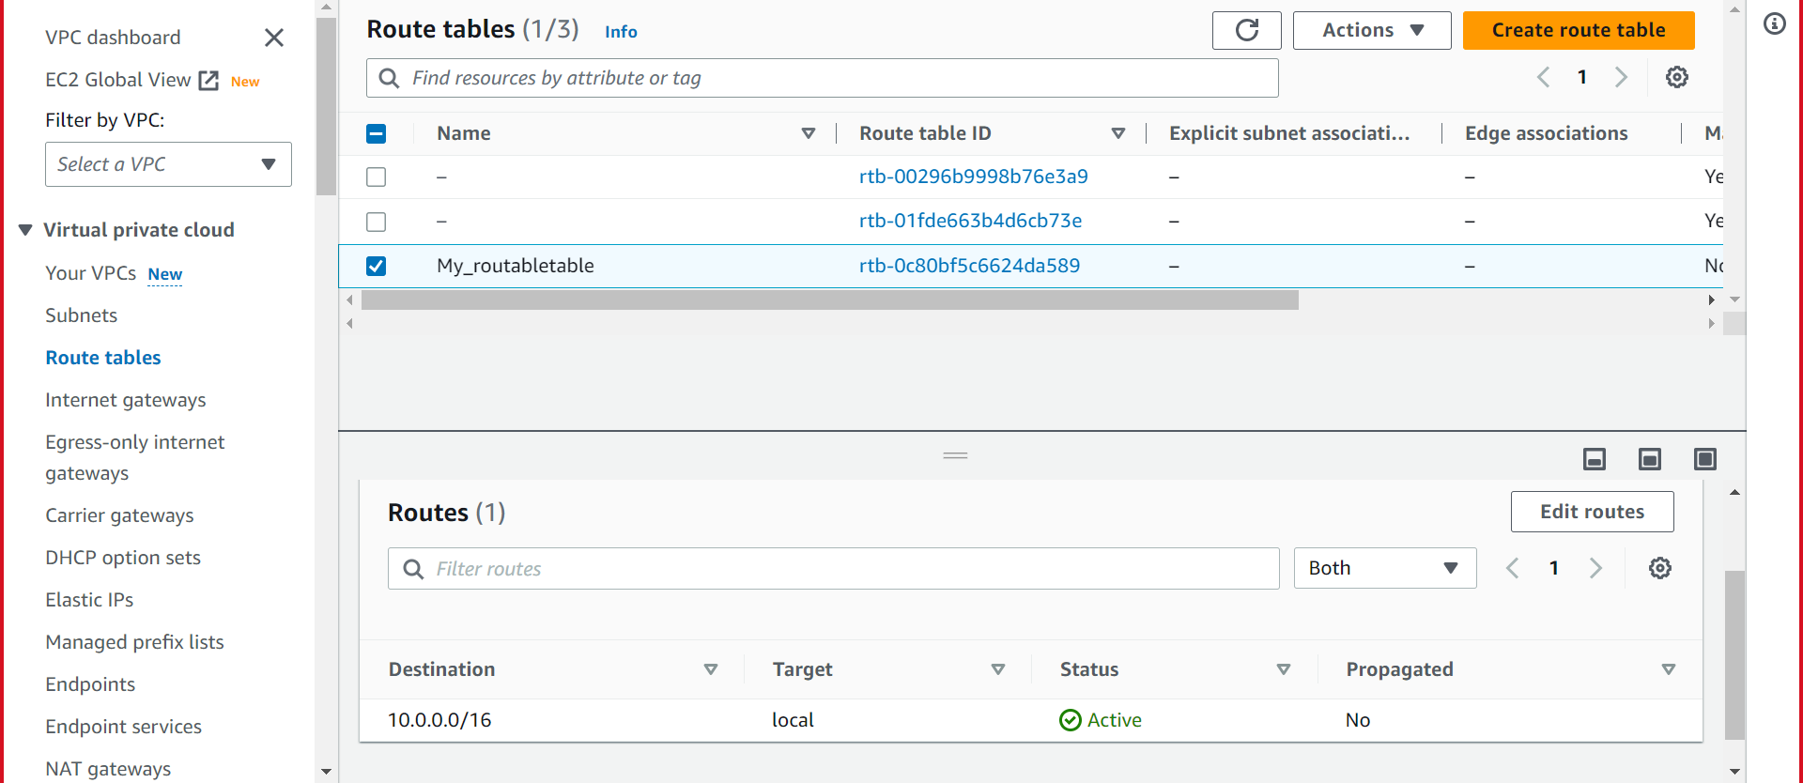

* Fill as show then save

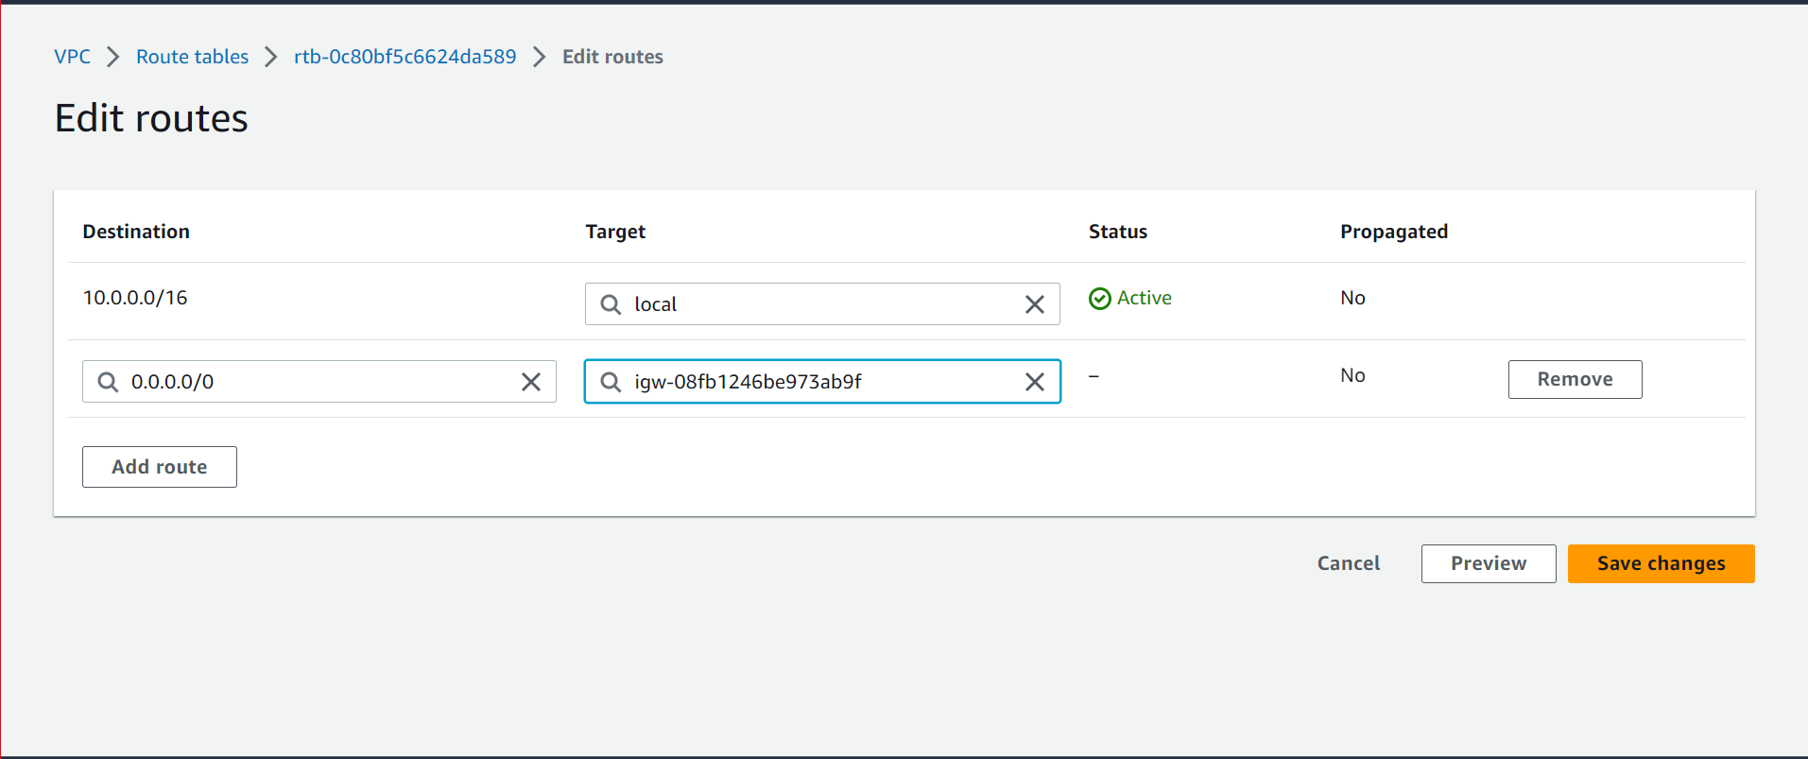

* Created

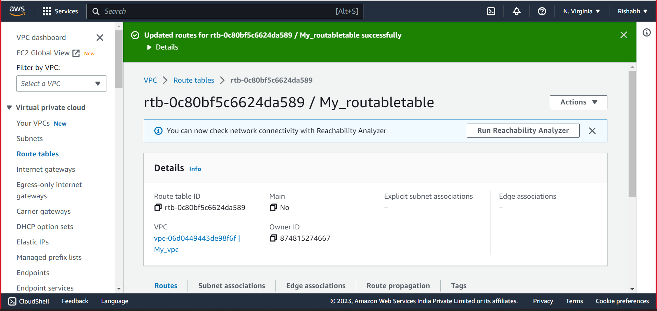

* Edit subnet associations

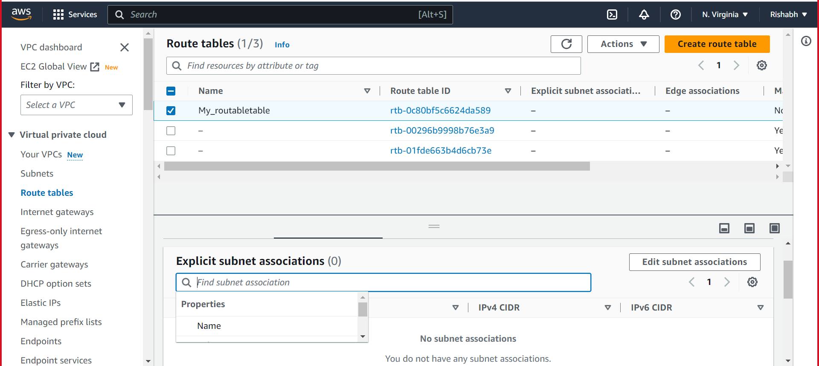

* Save Associations

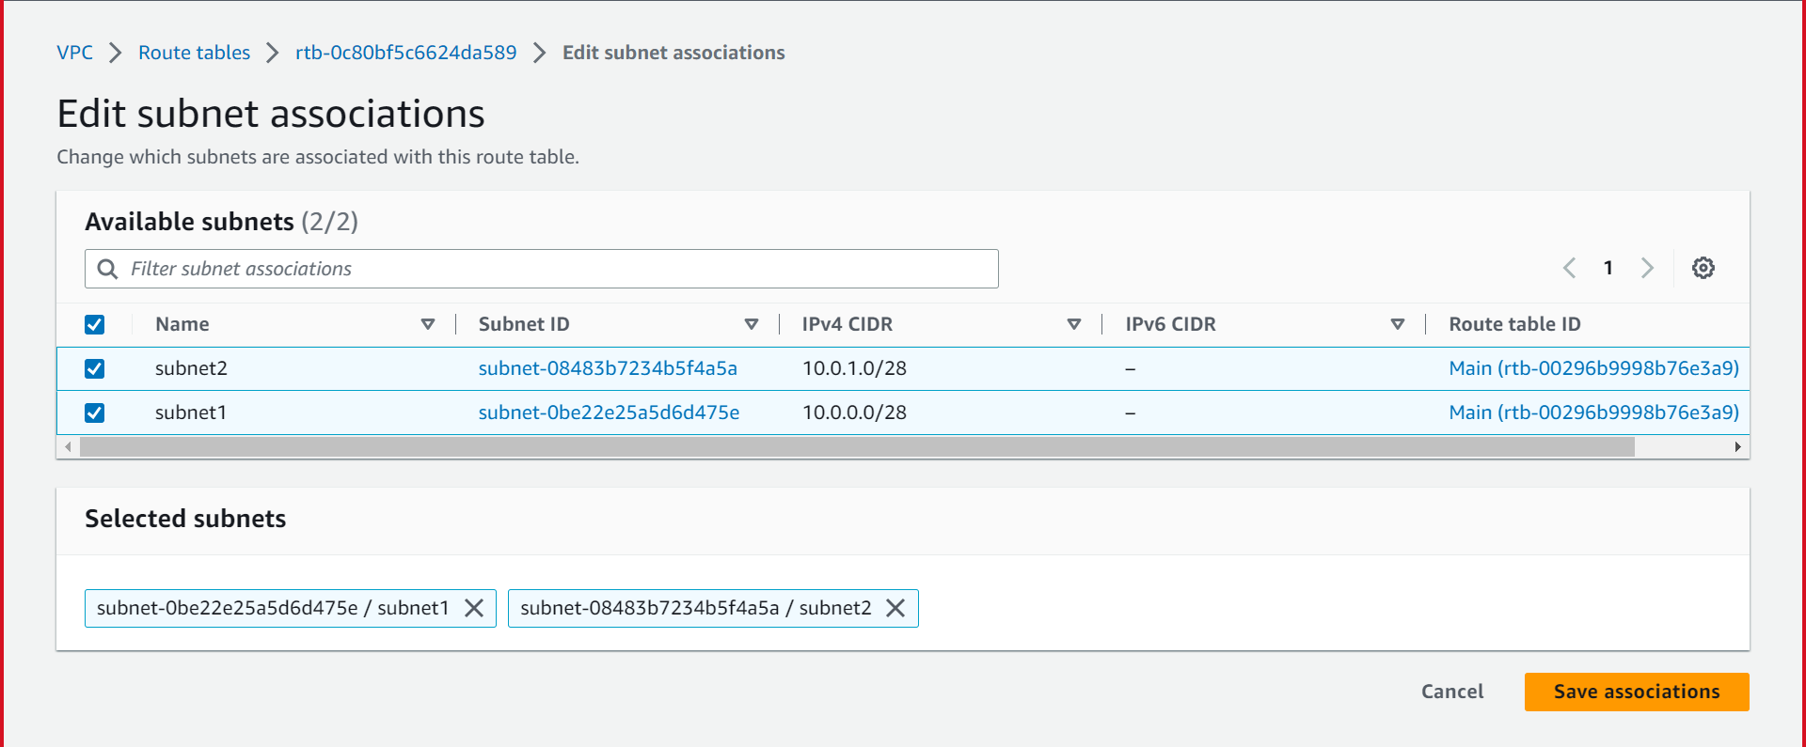

* Success

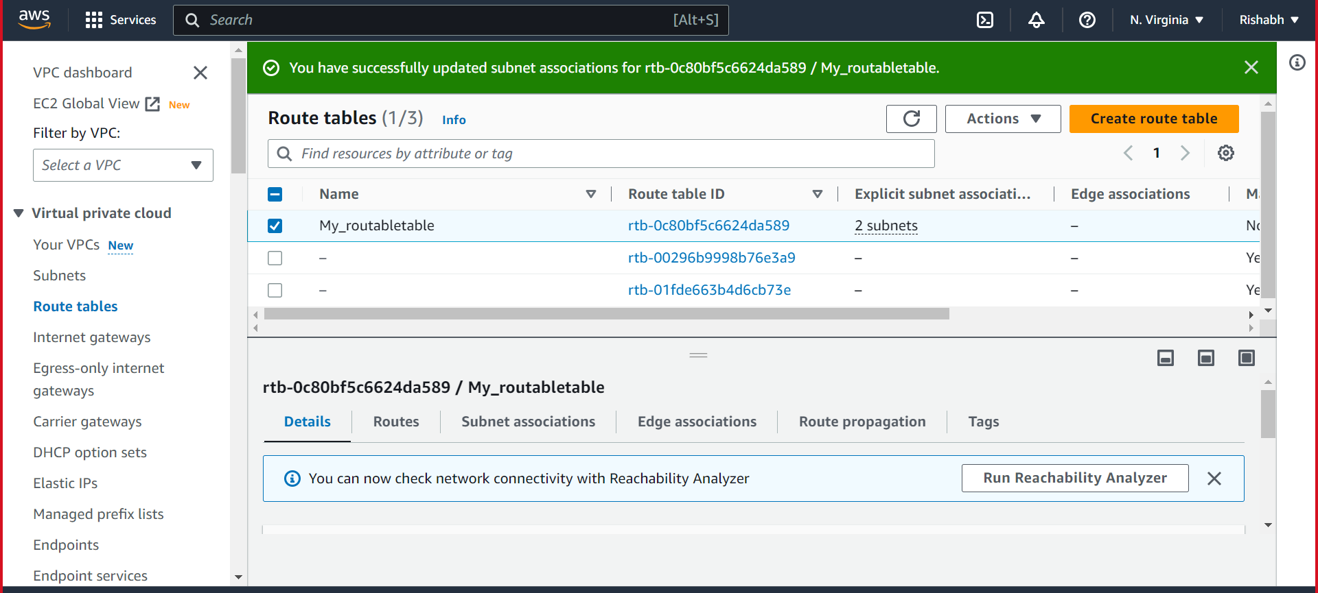

• Inside one of the subnets, create a VM and deploy an application code inside it (any existing application created by you before). Make sure to use appropriate NACLs and SGs.

Following are the steps

* Search EC2 click.

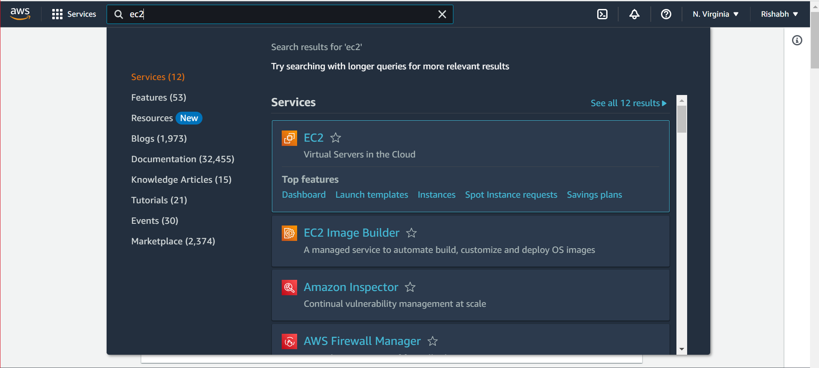

* Click launch instaance

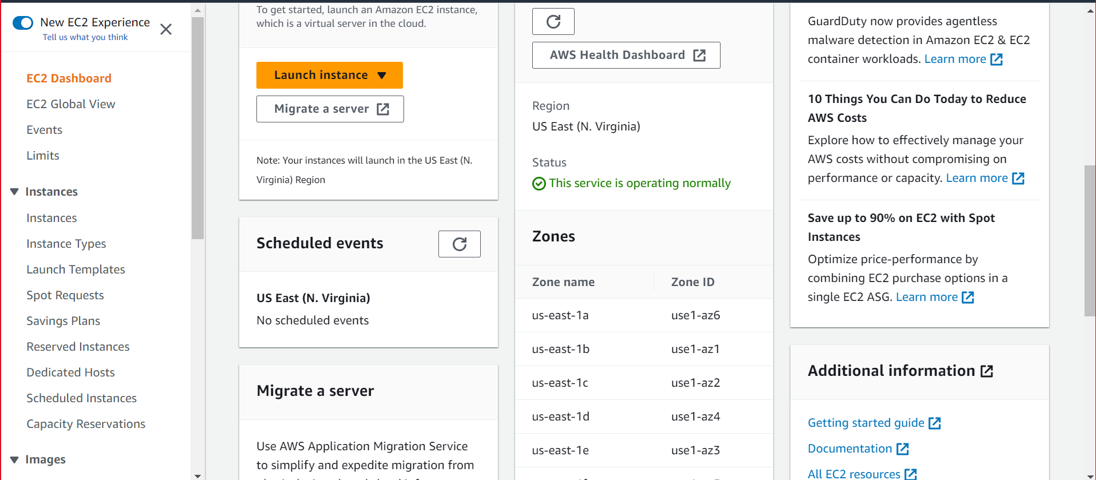

* Create new key

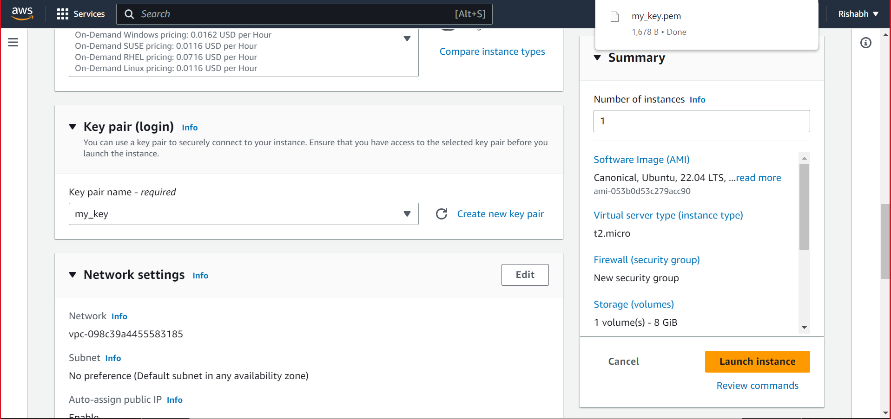

* Fill as shown

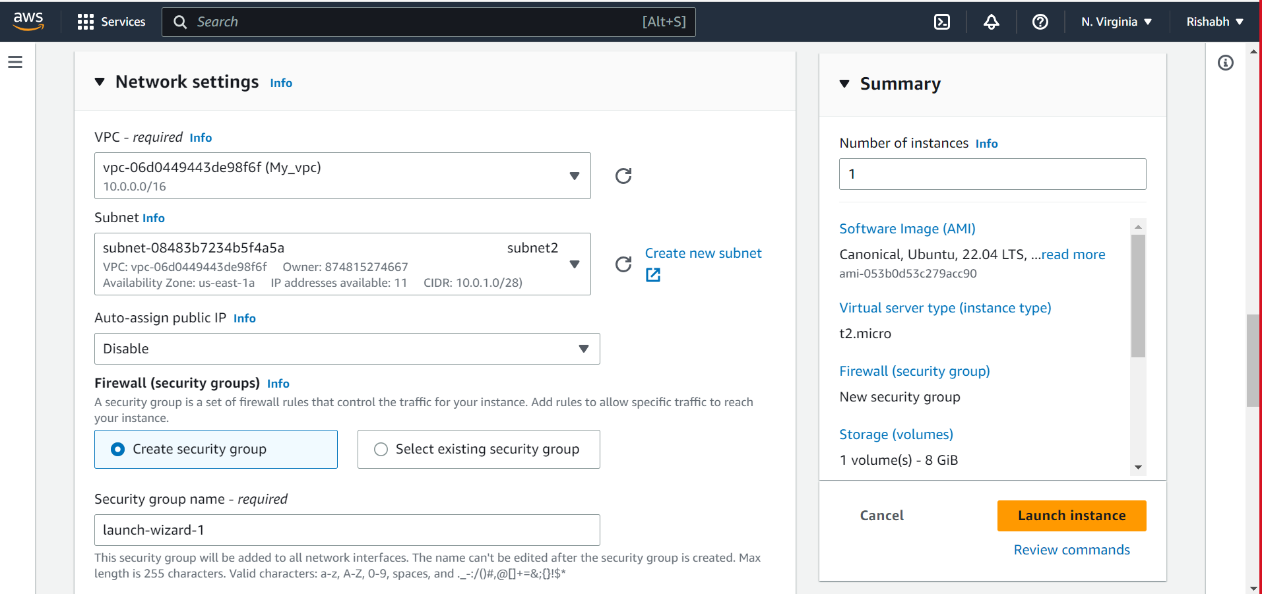

* Fill as shown

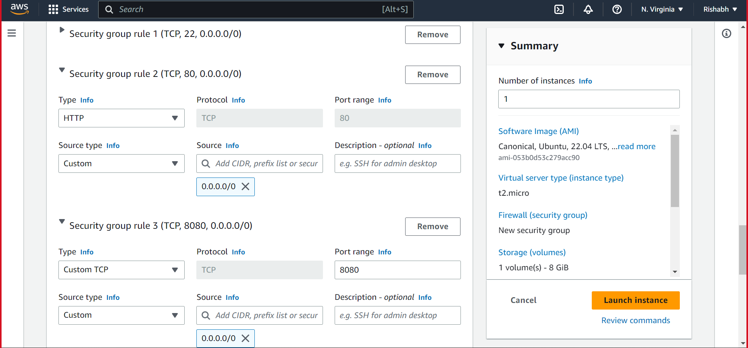

* Success

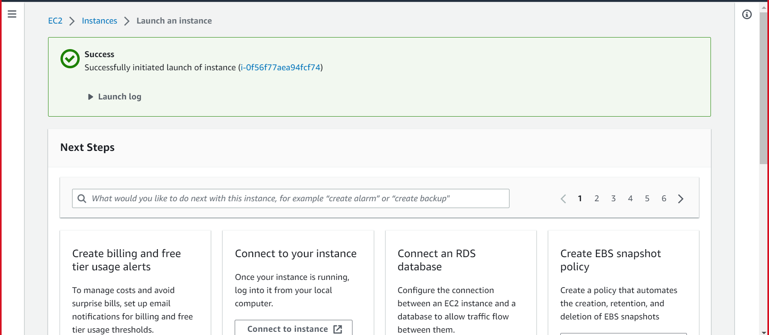

Now go cloud shell upload the key. And run the following command

* 1. curl -sL https://deb.nodesource.com/setup_14.x | sudo -E bash –
  2. sudo apt-get install -y nodejs
  3. node --version && npm –version ------to check node and npm version----
  4. wget -qO - https://www.mongodb.org/static/pgp/server-4.4.asc | sudo apt-key add –
  5. echo "deb [ arch=amd64,arm64 ] https://repo.mongodb.org/apt/ubuntu focal/mongodb-org/4.4 multiverse" | sudo tee /etc/apt/sources.list.d/mongodb-org-4.4.list
  6. sudo apt-get update.
  7. npm i.
  8. sudo apt-get install mongodb-org
  9. sudo systemctl start mongod.
  10. sudo systemctl status mongod.
  11. sudo systemctl enable mongod.
  12. sudo npm i pm2 -g.
  13. cd blogapp.
  14. pm2 start app.js.
  15. sudo apt install nginx.
  16. sudo vi /etc/nginx/sites-available/nodeApp.
  17. sudo ln -s /etc/nginx/sites-available/nodeApp /etc/nginx/sites-enabled.
  18. cd /etc/nginx/sites-enabled.
  19. sudo rm default.
  20. sudo service nginx restart.

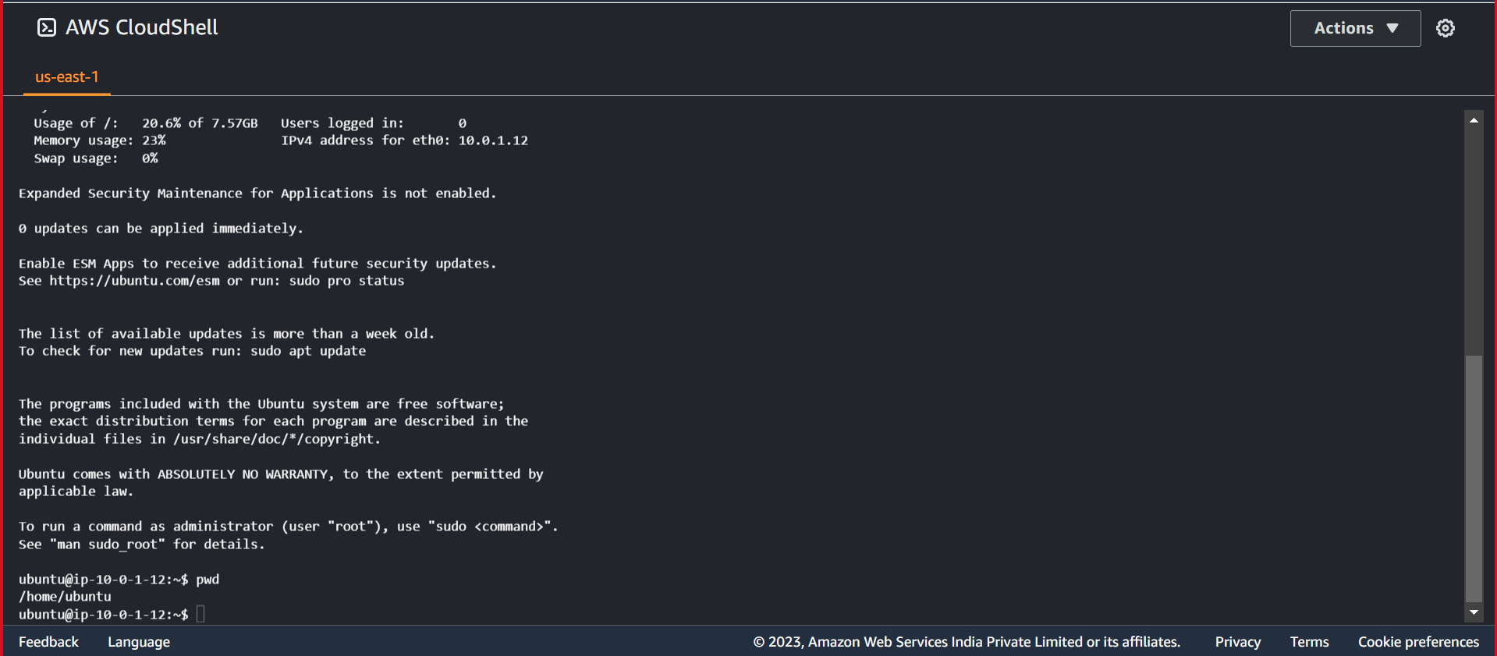

Now navigate to <http://204.236.208.9/> the app is up and running.

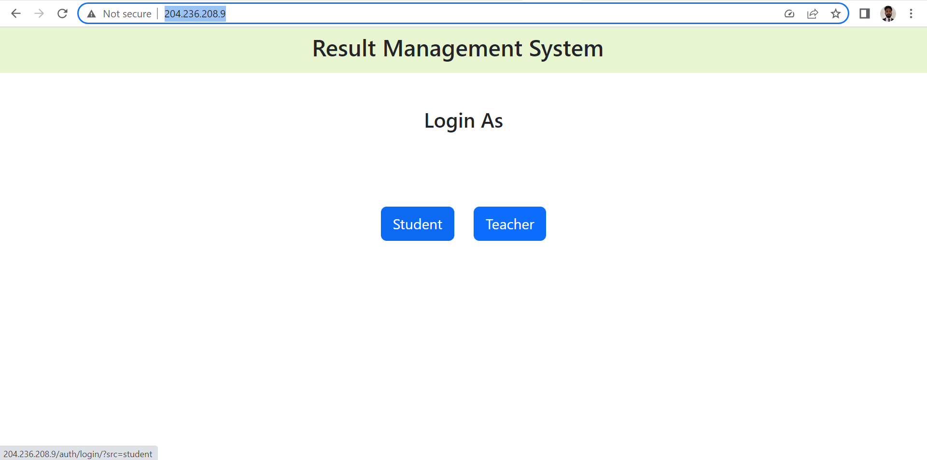



• Deploy the same application to Elastic beanstalk Service.

Following are the steps.

1. Create a cluster on MongoDB site. 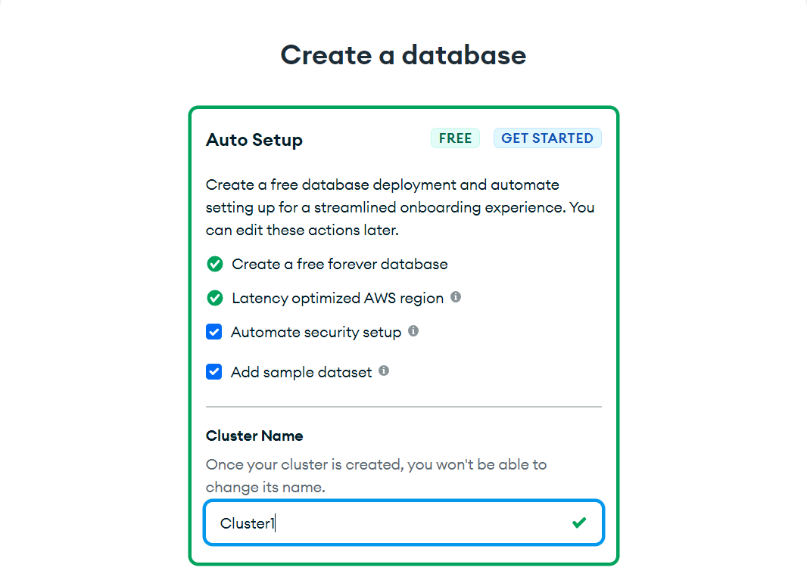 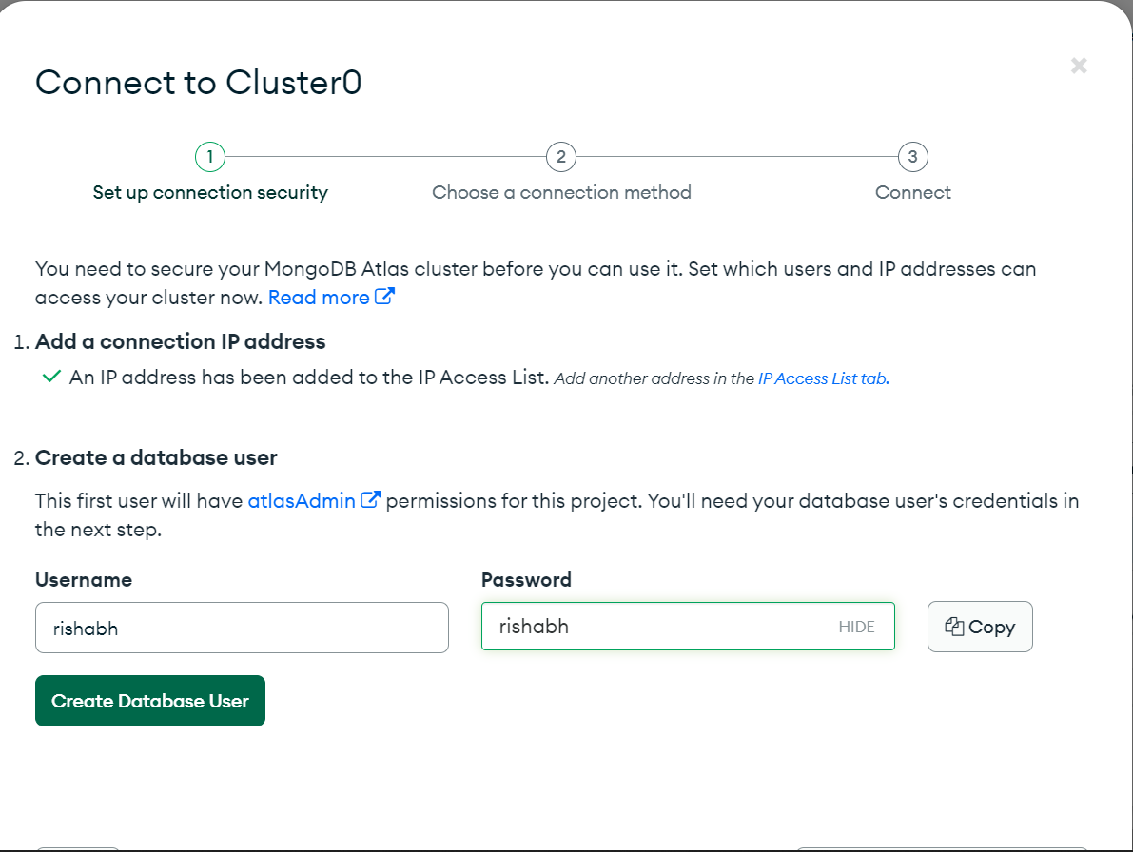
2. Search for Elastic Beanstalk. 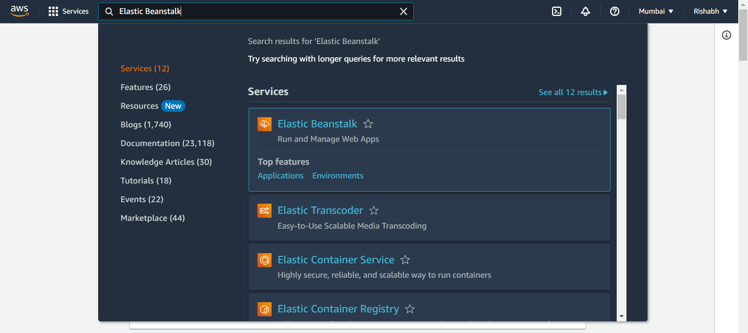
3. Click on create application. 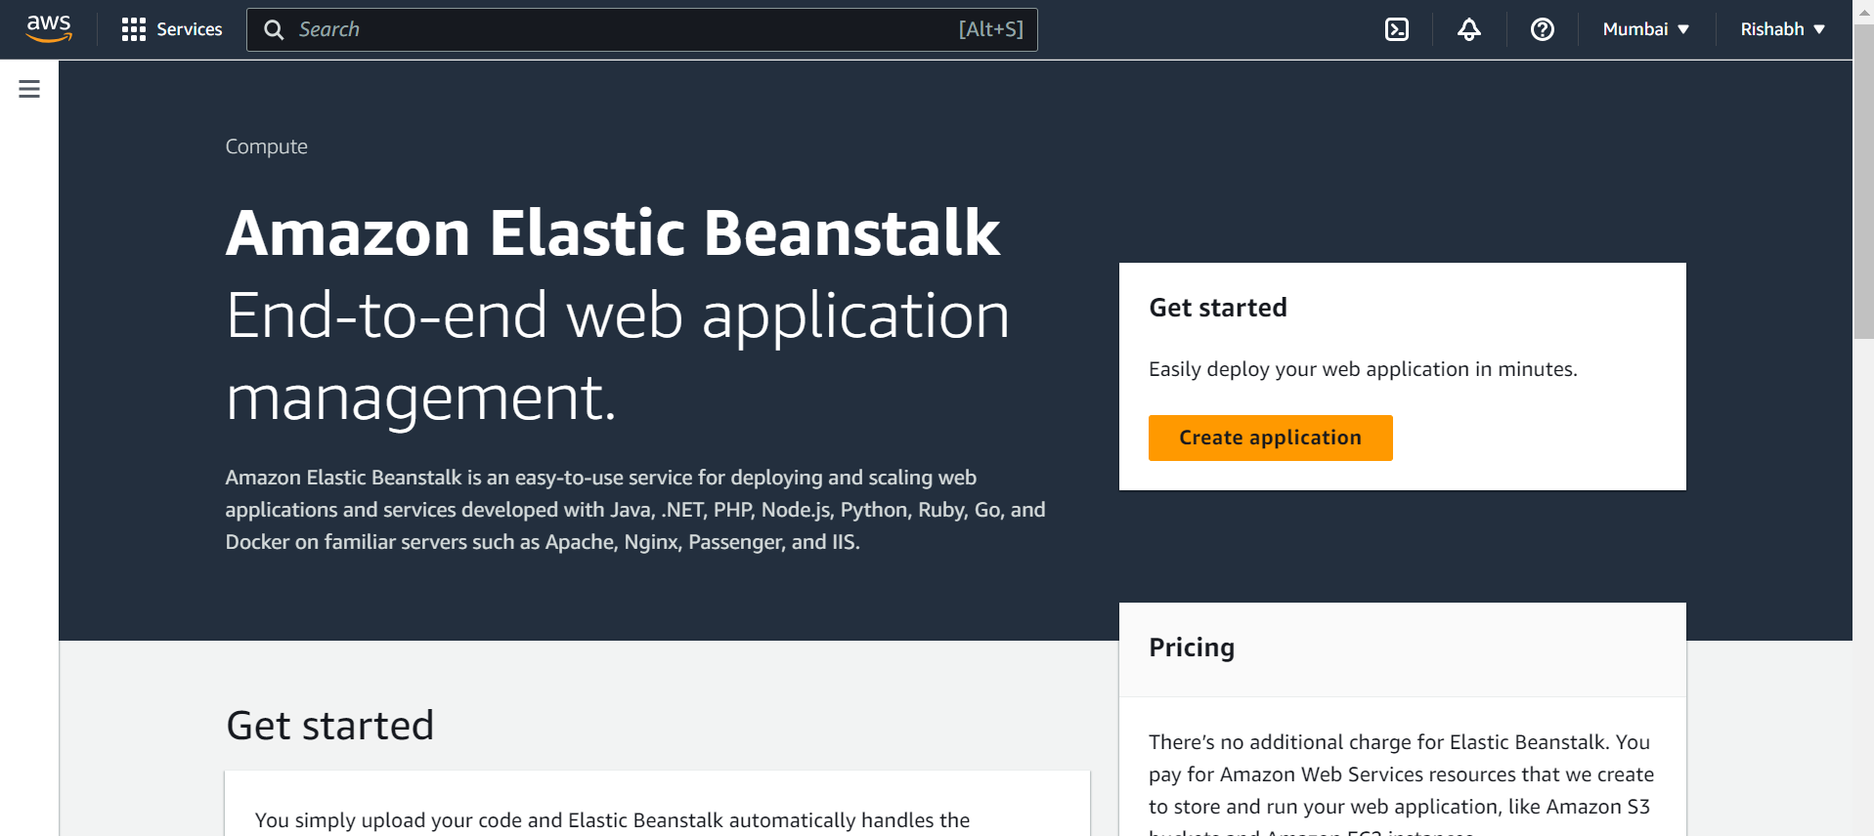
4. Fill as shown. 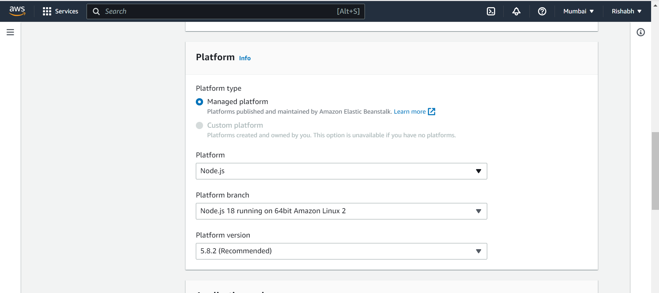
5. Upload your application. 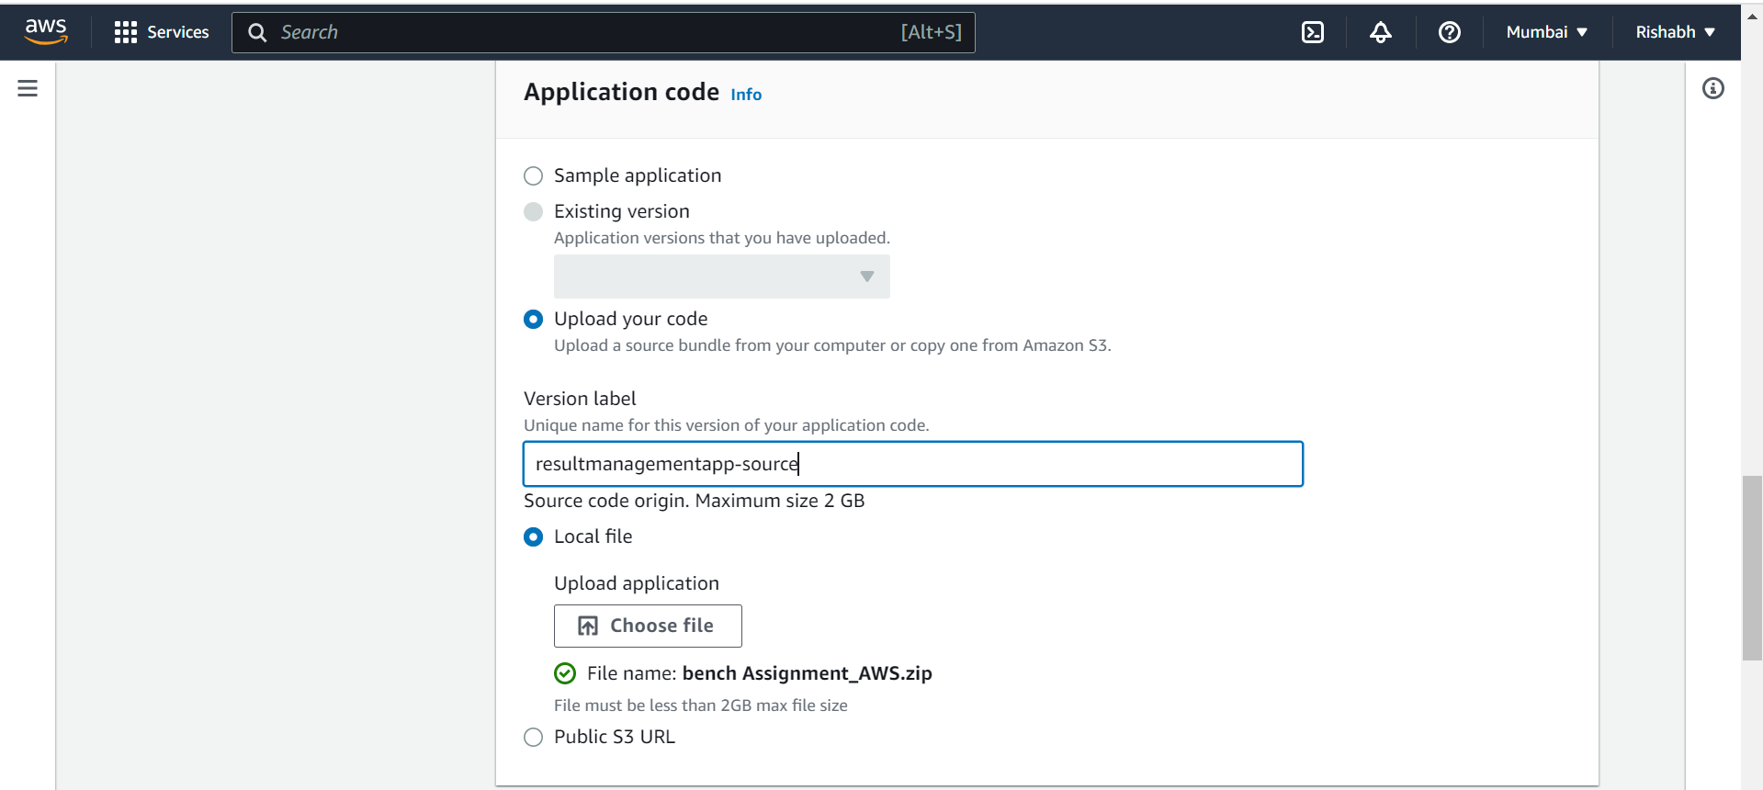
6. Choose as shown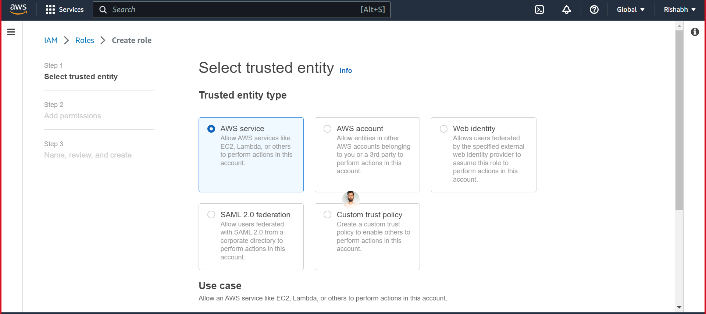
7. Click on next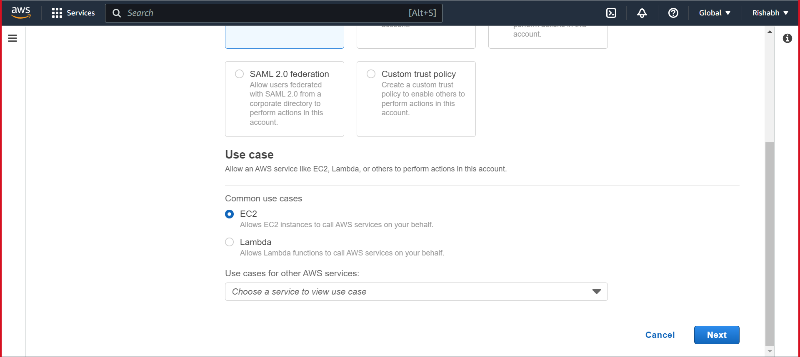
8. Add permissions as shown 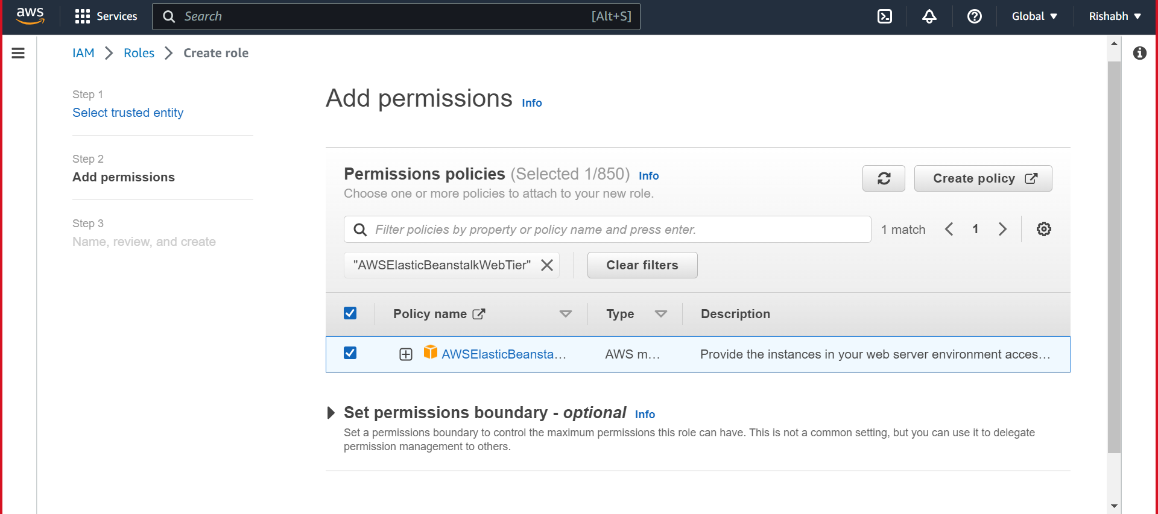
9. Create role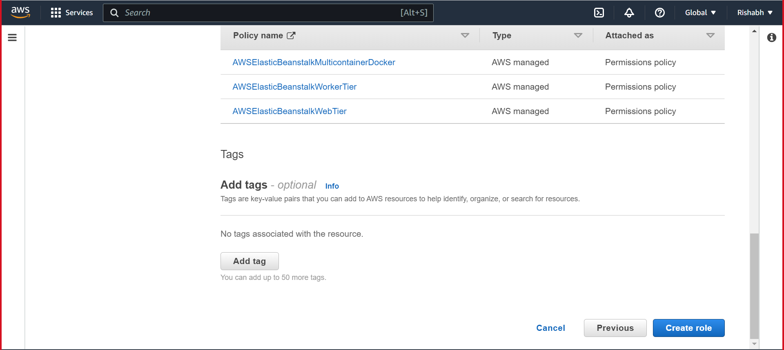
10. Submit.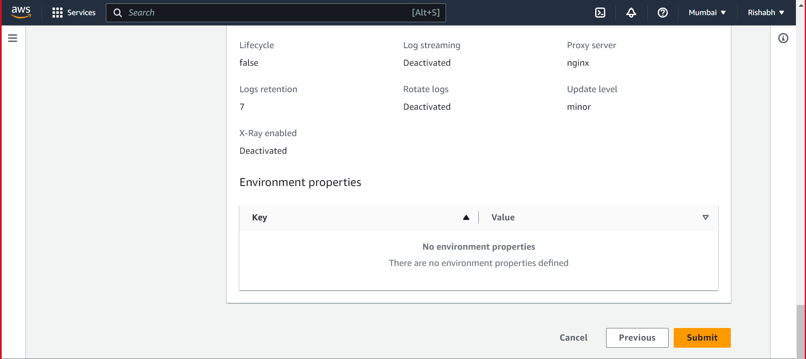
11. Add connection string for database. 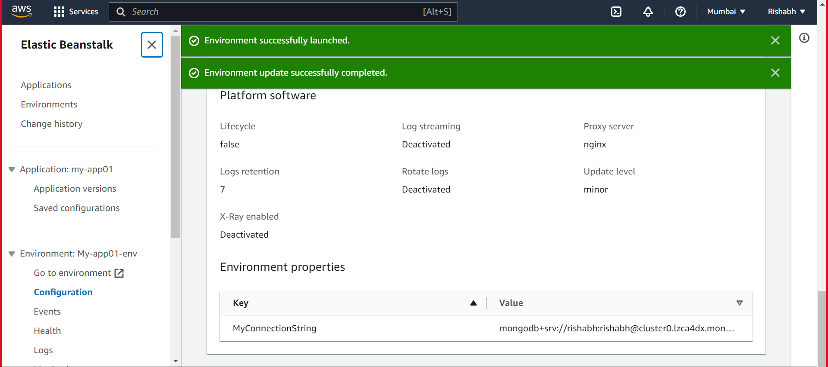
12. After Success the app is up and running. 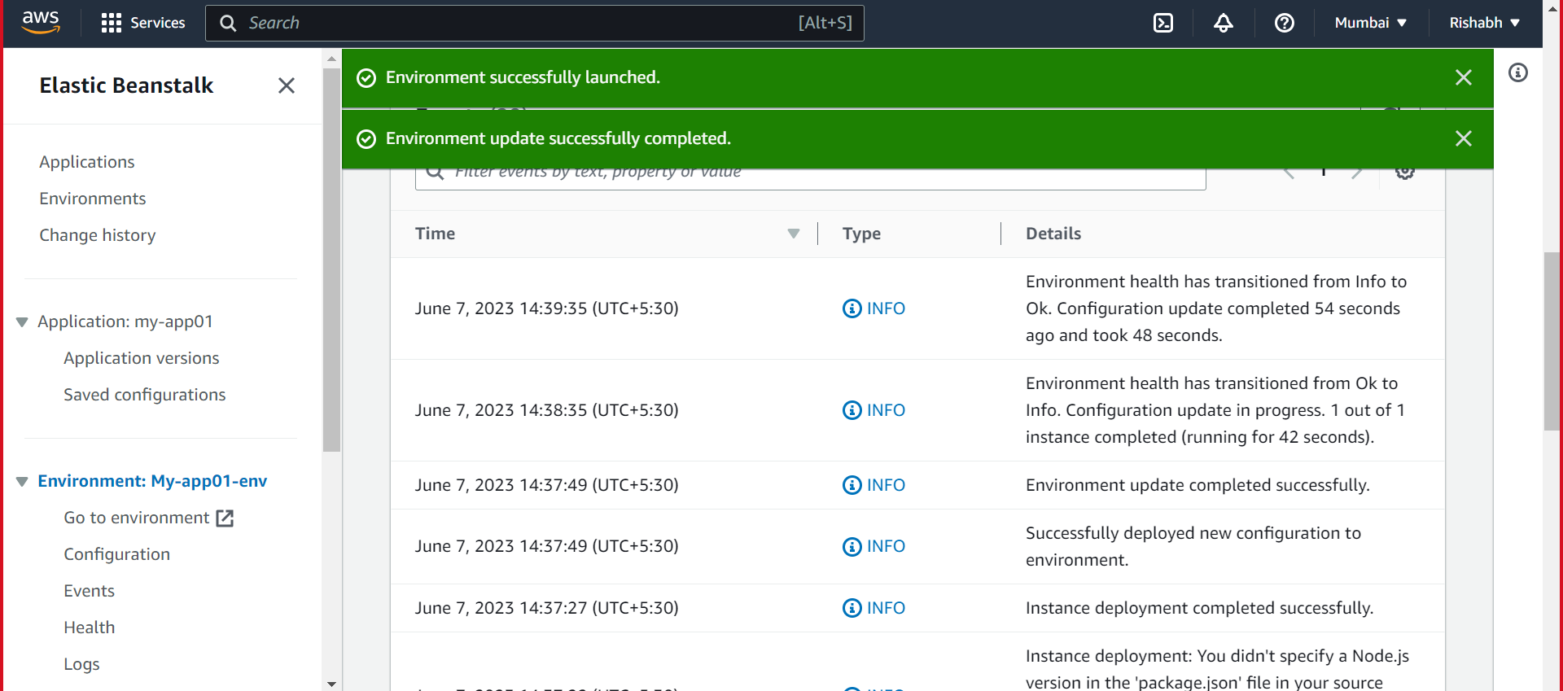
13. App running on “ [http://my-app01-env.eba-76znjwgu.ap-south-1.elasticbeanstalk.com/”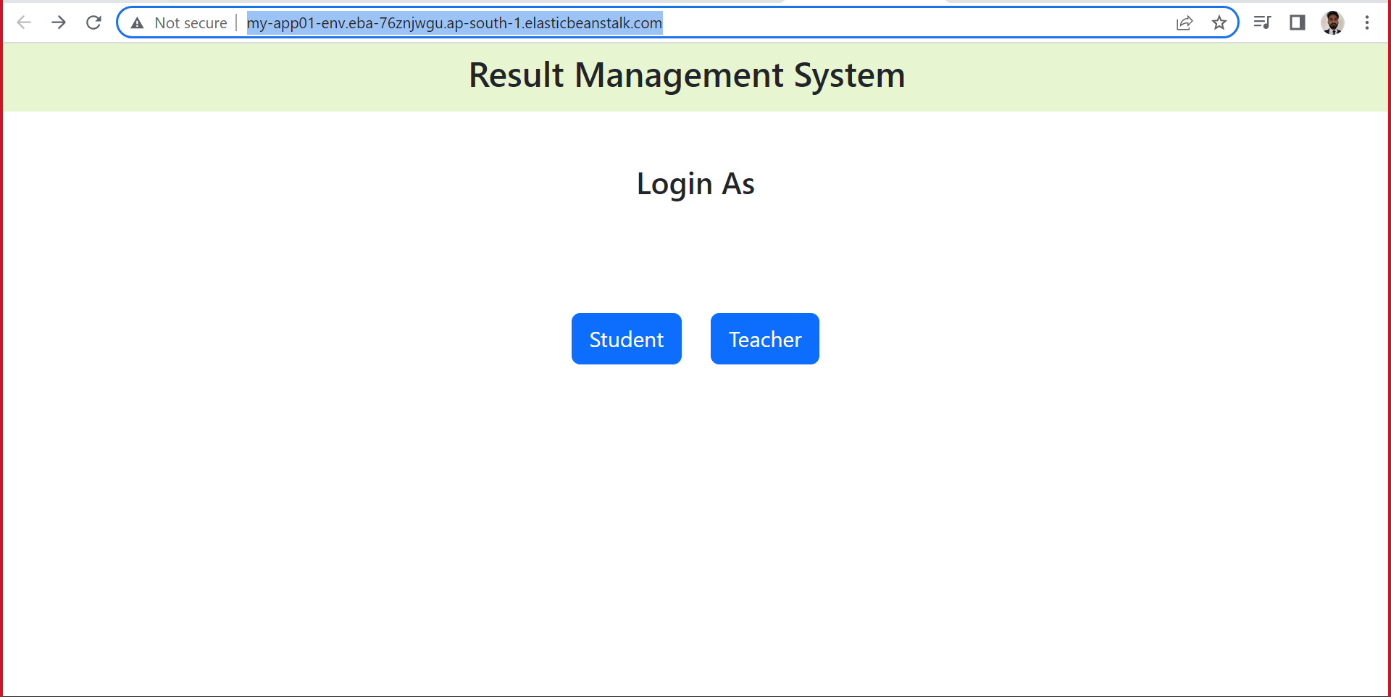](http://my-app01-env.eba-76znjwgu.ap-south-1.elasticbeanstalk.com/”#) 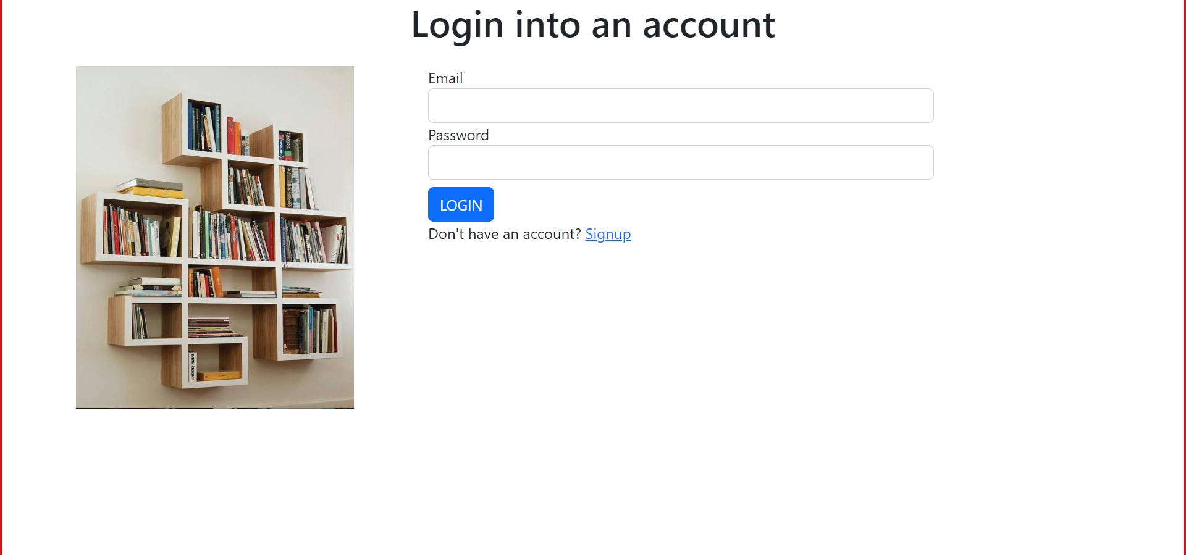

• Create a Lambda that should trigger as soon as you upload a file in the S3 bucket.

Function should be able to print the name of the file uploaded in the function.

Steps

1. Create a S3 bucket. 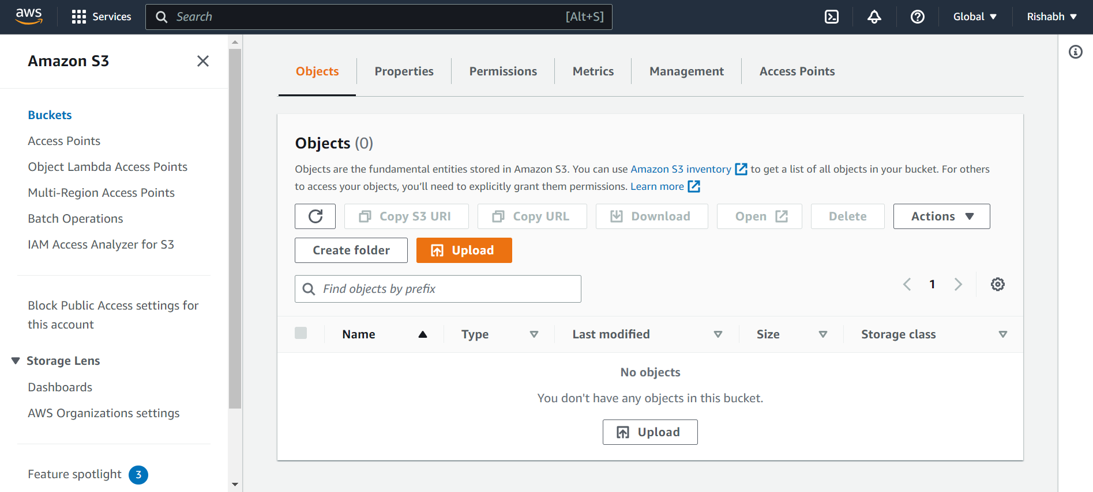
2. Search lamda. Click on create a function.
3. Fill as shown. 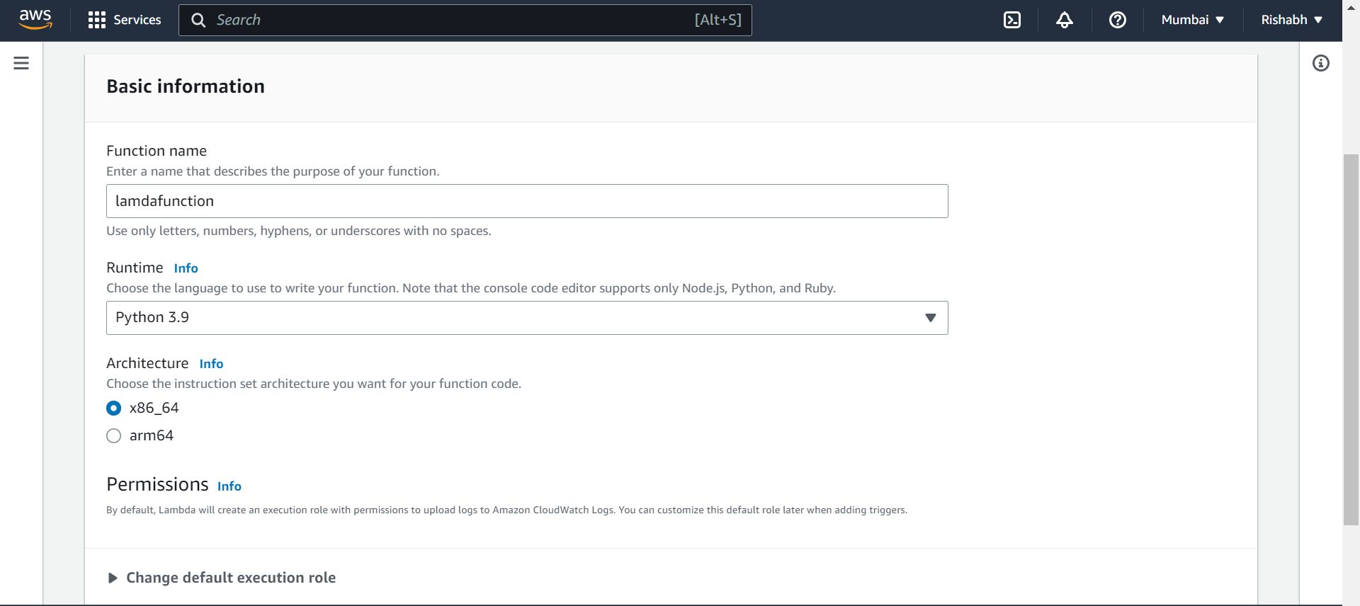
4. Fill as shown. Click on create function.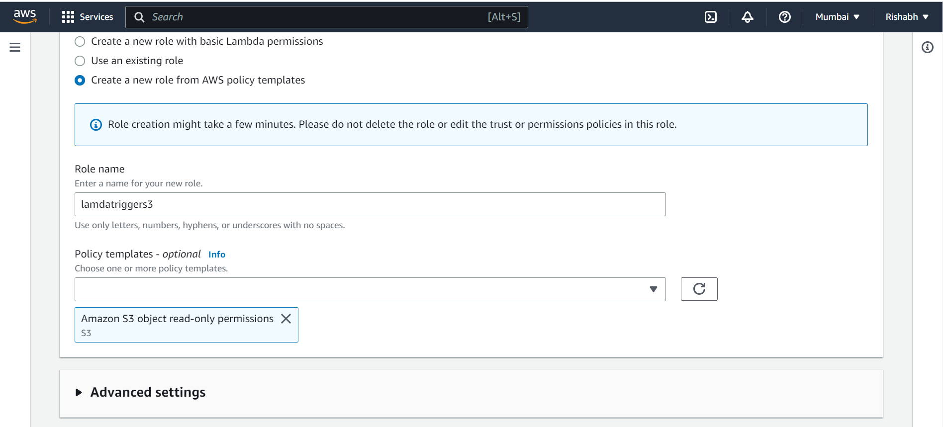
5. successful. 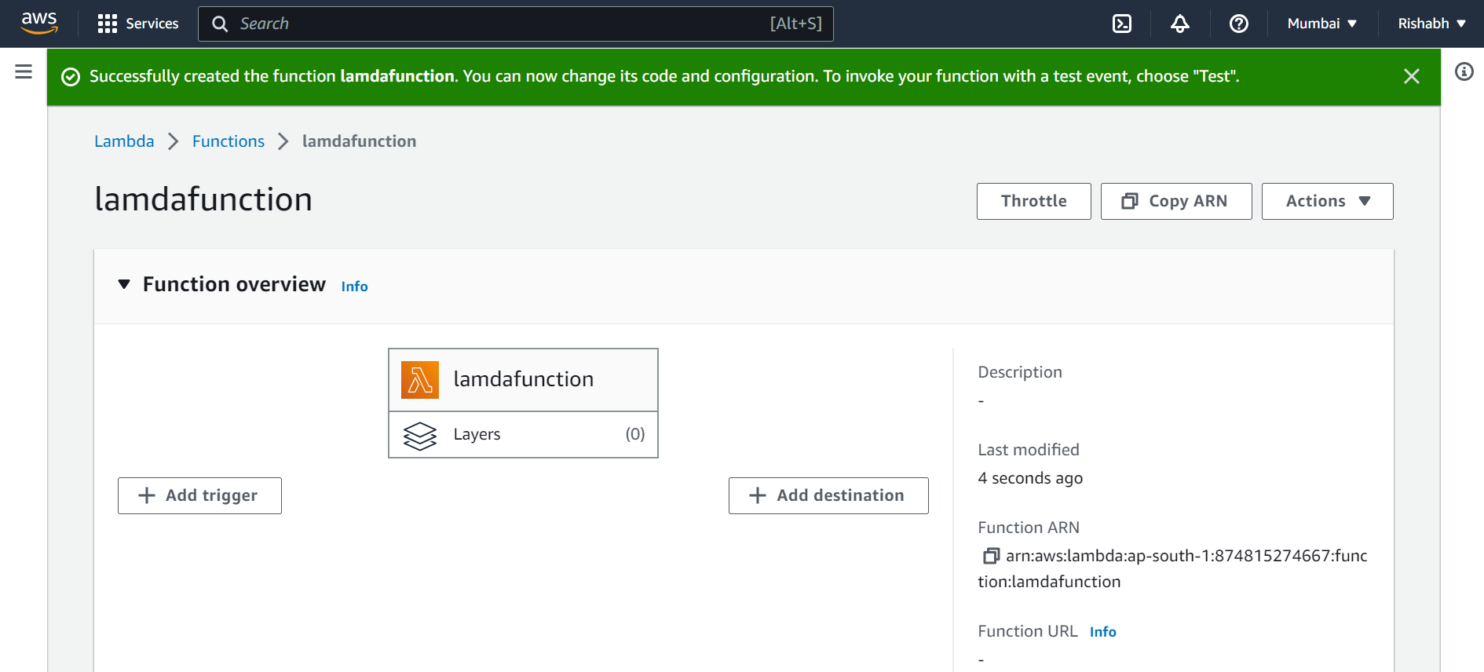
6. Create Event notification in s3. 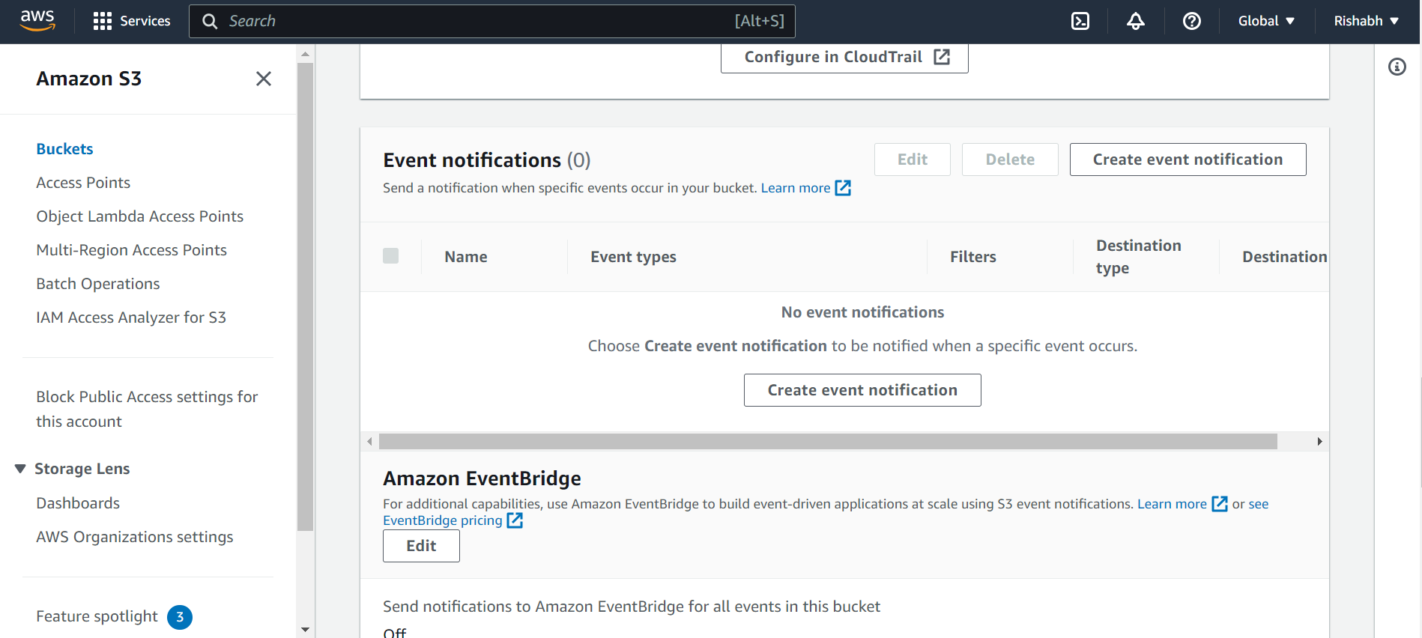
7. Save the changes. 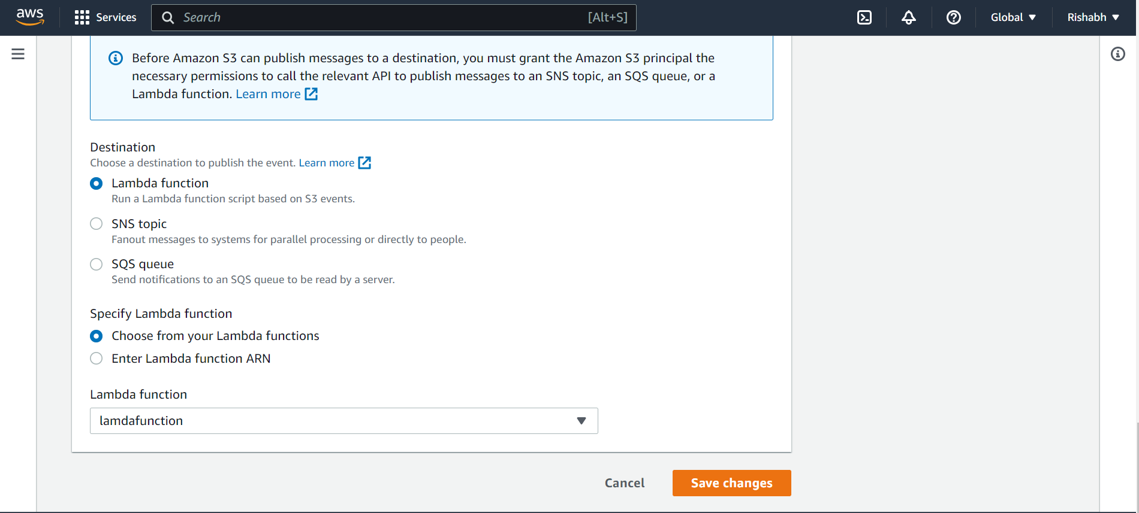
8. Successful. 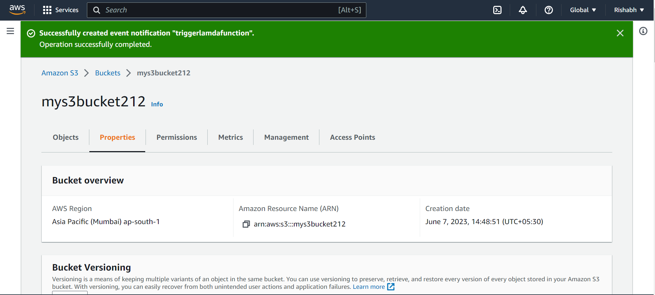
9. Deploy function. 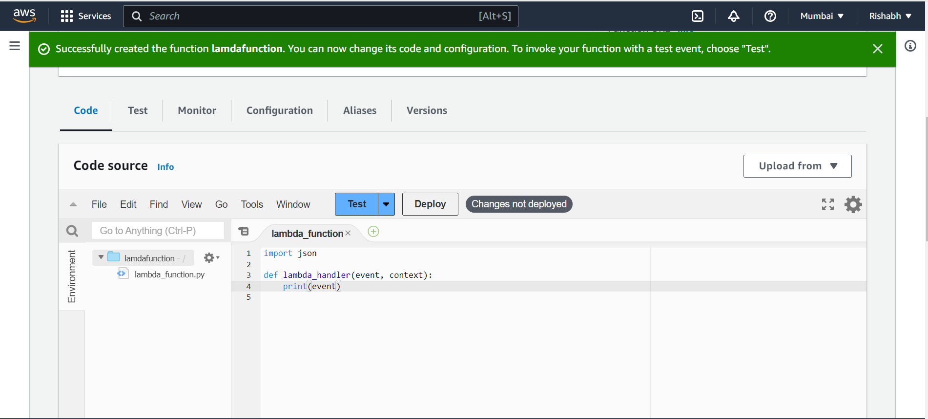
10. Upload a file in s3. 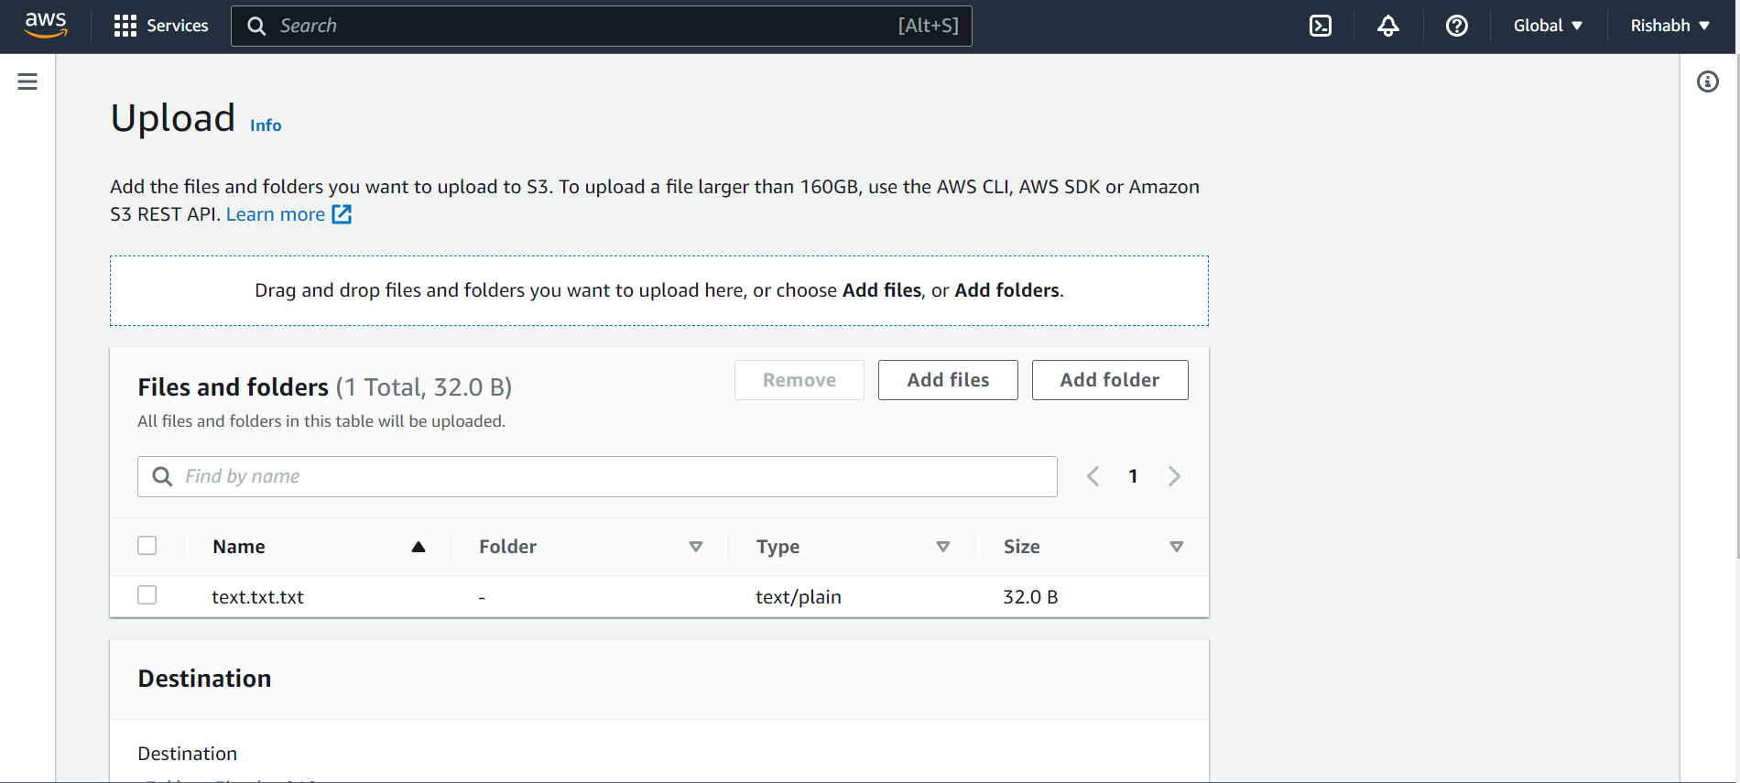
11. Upload success 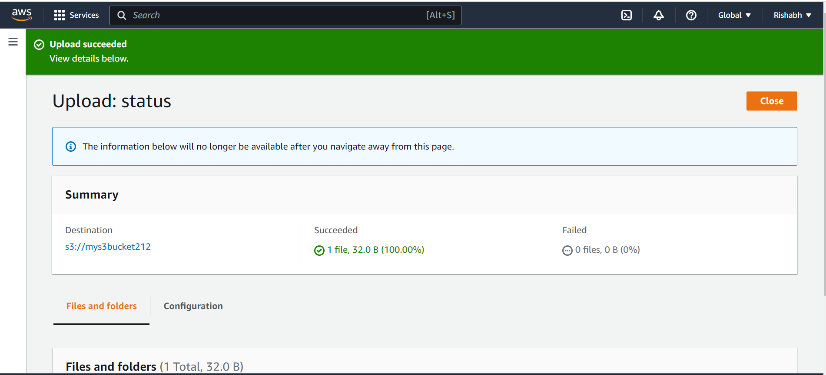
12. File is trigger and prints file name. 